

**MARKS**

**CO2: /50**

**CO3: /50**

**CO4: /25**

|  |  |
| --- | --- |
| Matric No. | Name |
| SD20018 | YAP KAH HUI |
| SD20033 | HAFIZ ASYRAAF BIN GHANI |
| SD20046 | THURGASHINI A/P MAHESWARAN |
| SD20056 | MUHAMMAD IZAT ESAMUDDIN BIN AWANG LAH |
| SD20041 | QIRYN ADRIANA BINTI KHARUL ZAMAN |

**Group No : 9**

**Lab Section : 02G**

**Lecturer : Dr Yusnita**

**Project Title : Home Surveillance Quarantine System**

**Faculty of Computing**

**Universiti Malaysia Pahang**

**BCI2023 Database Systems**

**Semester 1 2021/2022**

**Table of contents**

1. Part 1: Proposal of database system

1.0 Introduction 3

2.0 Comparison between two databases 4-8

3.0 Business Rules of Proposed System 9

4.0 ERD & EERD of Proposed System 10

1. Part 2: SQL & Normalization

5.0 Data Definition Language (DDL) 11-22

6.0 Data Manipulation Language (DML) 23-39

7.0 Normalization 40-41

8.0 Data Dictionary 42-44

9.0 References 45

10.0 Appendix 46-47

**1.0 Introduction**

**Background**

The title for this project is Home Surveillance Quarantine System. By creating this system, the problem of long queues outside the clinic can be reduced. This system stores personal information like identity card (IC) number, address, phone number, vaccination status, locations visited and more. Furthermore, this system does have a section that allows the user to answer an assessment, it includes a few questions like if they have any COVID-19 symptoms, if they have attended any areas associated with known COVID-19 clusters, and if they have close contact with suspected cases of this disease.

After they have done answering the questions and it is found that they have been exposed to the virus, the user will get an order from this system to quarantine themselves at home for at least seven days. Users can also fill up their dependents’ information in the system. Dependent means senior citizens that do not use smartphones or any underage person like their childrens. They can update their well-being everyday by answering the assessment. The medical team can proceed with their procedures if they find that someone has been diagnosed with COVID-19 symptoms. The system can also locate the locations that have been exposed to the virus and the data can be shared to people so they can avoid going to that place. The individuals that insisted on entering Malaysia from other countries can also use this system.

The details of this project are about how the data is being kept or managed by the database system of the Home Surveillance Quarantine System. The entities or objects that can be found in this database system are Applicant, Individuals Entering Malaysia, Transportation, Daily Health Assessment, Test, Traveller, Applications,and Vaccination. The examples of data and information that can be recorded or stored in the system are those who have been involved in this business and their attributes. Not only that, any tasks involved will be stored as well.

    In conclusion, this system provides a convenient service for the citizens, government, and medical teams. With this system, it can bring more benefits, thus, we can reduce the spread of COVID-19 and protect our loved ones. 

**Scope (System and User)**

    Home Surveillance Quarantine System is a system to release an order for people to quarantine themselves at home after they have been exposed to COVID-19. Anyone can use it anywhere and anytime online. This system stores all data and information about the users, their dependents, their vaccination status and more.

This system will be able to:

* Release an order to people to quarantine themselves if they are identified as close contact
* Stores Home Surveillance System applicants’ information
* Show the users about their status after completing the daily health assessment
* Show the users their vaccination status

As for the user scope, users are able to:

* Create an account and log in to the system
* Apply for a home surveillance in hospital or at home
* Send an application to enter Malaysia by filling up their information.

**Objectives**

* Monitoring their symptoms and ensuring the early detection of COVID-19 cases
* Changing the users’ COVID-19 risk status to avoid them from entering premises.

**2.0 Comparison between two databases**

The two databases that are chosen for our study in this project are MySejahtera Database and eCovid-HQA Database.

|  |  |  |
| --- | --- | --- |
|  | MySejahtera Database | eCovid-HQA Database |
| Entities | * User * Dependent * COVID-19 Vaccination * COVID-19 Risk Status * COVID screen * COVID-19 Self-Test * Health Facilities * Location * Place visited | * Applicant * Individual entering Malaysia * Travel * Quarantine |
| Attributes | * User * user_ic_no * user_name * user_gender * user_age * user_address * user_postcode * user_state * user_phone * dependent_ic * vaccination_status * risk_status * Dependent * dependent_ic_no * dependent_relation * dependent_name * dependent_age * dependent_gender * dependent_address * dependent_postcode * dependent_state * COVID-19 Vaccination * vaccination_process_code * vaccination_status * user_ic_no * COVID-19 Risk Status * risk_status_code * risk_status_symptom * COVID screen * screen_code * test_type * test_result * COVID-19 Self-Test * selftest_referenceNo * user_ic_no * user_name * place_testkit_obtained * sample_type * test_outcome * Health Facilities * facilities_no * facilities_name * facilities_address * facilities_phone * Location * location_code * location_address * location_risk * Place visited * place_code * place_address * place_name * user_ic_no * date_visited * time_visited | * Applicant * applicant_id * applicant_name * applicant_phone * applicant_email * applicant_arrivalDate * Individual Entering Malaysia * individual_id * individual_name * individual_nationality * individual_DOB * individual_gender * individual_1stdoseDate * individual_2nddoseDate * individual_vacType * Travel * travel_departureCountry * travel_departureDate * travel_entryPoint * individual_id * Quarantine * address_referenceNo * quarantine_address * quarantine_postcode * quarantine_state * quarantine_district |
| Primary Key/Foreign Key | * **User**   PK: user_ic_no  FK: dependent_ic_no   * **Dependent**   PK: dependent_ic_no  FK: user_ic_no   * **COVID-19 Vaccination**   PK: vaccination_process_code  FK: user_ic_no   * **COVID-19 Risk Status**   PK: risk_status_code  FK: user_ic_no   * **COVID screen**   PK: screen_code   * **COVID-19 Self-Test**   PK: selftest_referenceNo   * **Health Facilities**   PK: facilities_no   * **Location**   PK: location_code   * **Place visited**   PK:place_code | * **Applicant**   PK: applicant_id   * **Individual entering Malaysia**   PK: individual_id   * **Travel**   PK: travel_departureCountry  FK: individual_id   * **Quarantine**   PK: address_referenceNo |
| Relationship | -Each user can have one or many dependent  -Each dependent has only one user  -Each user can have one COVID-19 vaccination  -Each COVID-19 vaccination is for one or many user  -Each user has only one COVID risk status  -Each COVID risk status can have many user  -Each user may undergo zero to many COVID screen  -Each COVID screen undergone by one user  -Each user may report zero or many COVID-19 self-test result  -Each COVID-19 self-test result is reported by only one user  -Each Health Facilities conduct many COVID screen  -Each COVID screen is conducted by one Health Facilities  -Each user can view only one location risk  -Each location risk is viewed by many user  -Each user may visit zero to many places for past one month  -Each place is visited by many users for past one month | -Each applicant can apply for one or more individuals to enter Malaysia.  -Each HQA of individual entering Malaysia is applied by one applicant only  -Each individual entering Malaysia has only one travelling information  -Each travelling information is from one or many individuals entering Malaysia  -Each applicant applies for one quarantine place  -Each quarantine place has one to many individuals entering Malaysia |
| References | <https://mysejahtera.malaysia.gov.my/intro/> | <https://hso.moh.gov.my/outbreak-portal-hqa/traveller/hqareg> |

**MySejahtera Database**

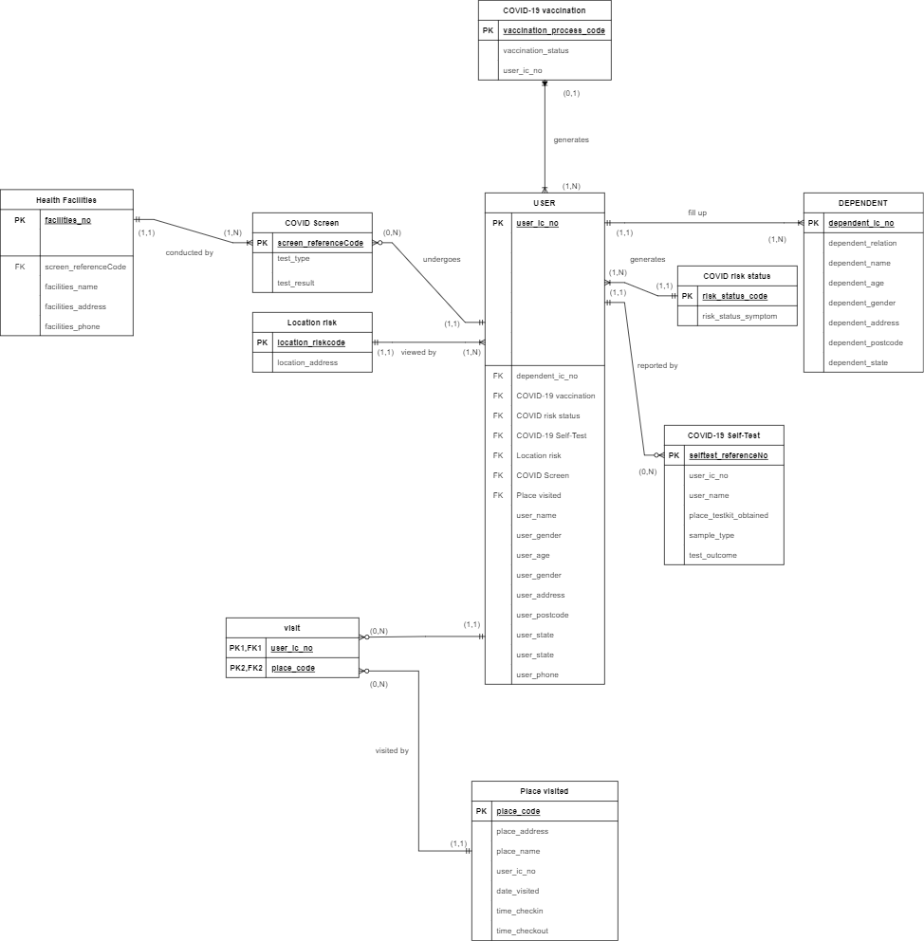

User entity stores all the details of the MySejahtera registered users.

Dependent entity is used to store data about the User’s family members who do not own smartphones.

COVID risk status entity stores data about the User’s health status (low risk no symptom, low risk with symptom…).

COVID-19 Self-Test is the entity which stores the data when User report the result of their self-test kit.

COVID Screen is the entity which stores the data when the User undergoes covid screen.

Location risk is the entity which stores the risk status of each location. (Eg: Taman Mutiara – Red Zone).

Entity Health Facilities stores data about the health facilities which provide COVID screen.

Place visited entity stores data about the location details, the User visited and time when User check in and check out.

**ecovid-HQA database**

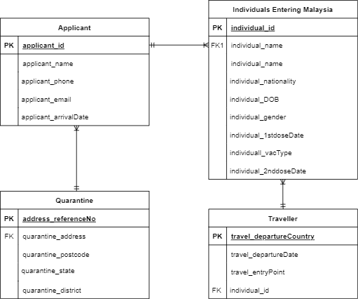

Applicant entity stores data about the applicants’ details.

Applicant apply home quarantine for Individuals Entering Malaysia. Individuals Entering Malaysia stores data about the individuals entering Malaysia who has submitted their application for home quarantine.

Quarantine entity stores data about the details where the Individuals Entering Malaysia are having their quarantine at.

Traveller entity stores travelling data about the Individuals Entering Malaysia.

**3.0 Business Rules of Proposed System**

|  |  |  |  |
| --- | --- | --- | --- |
| Business rules | Entity | Relationship | Entity |
| -Each applicant can submit one or many application  -Each application is submitted by one applicant | Applicant | 1:M | application |
| -An applicant has one and only one vaccination status  -COVID-19 vaccination status is for all applicant | Applicant | 1:M | Vaccination |
| -Each application consists one to many individuals entering Malaysia information  -Each individual entering Malaysia information has submitted one application | Application | 1:M | Individual entering Malaysia |
| -Each application has only one travelling information  -Each travelling information is from one or many application | Application | M:1 | Traveller |
| -Each traveller takes only one transportation to depart to Malaysia  -Each transportation can have one or many traveler | Traveller | M:1 | Transportation |
| -Each traveller must complete one daily health assessment  -Each daily health assessment is completed by one traveller | Traveller | 1:1 | Daily health assessment |
| -Each traveller undergoes one or many test  -Each test is undergone by one traveller | Traveller | 1:M | Test |
| -Each application included a quarantine address  -Each quarantine address has one to many application | Application | M:1 | Quarantine |

**4.0 ERD and EERD of Proposed System**

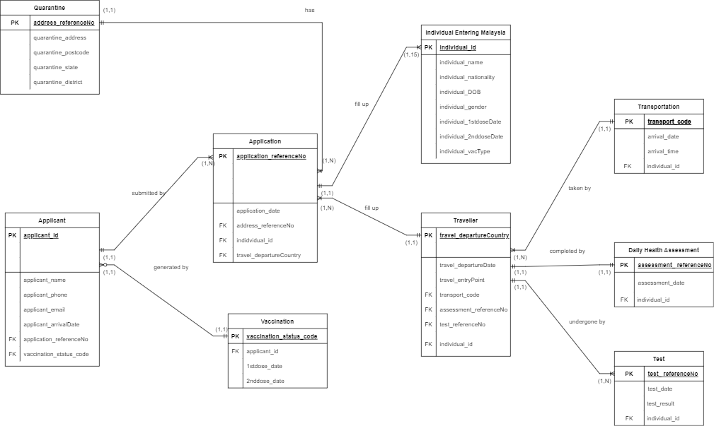

Figure 4.1: Proposed ERD of our Home Surveillance System

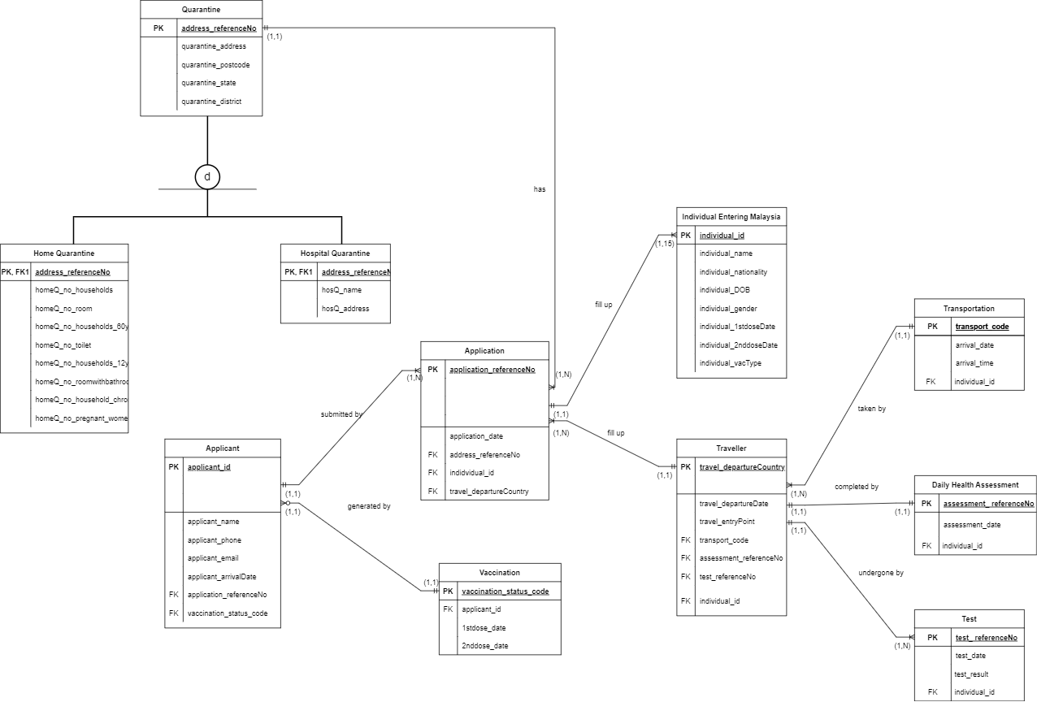Figure 4.2: Proposed EERD of our Home Surveillance System

**5.0 Data Definition Language (DDL)**

**CREATE DATABASE**

create database home_quarantine_system;

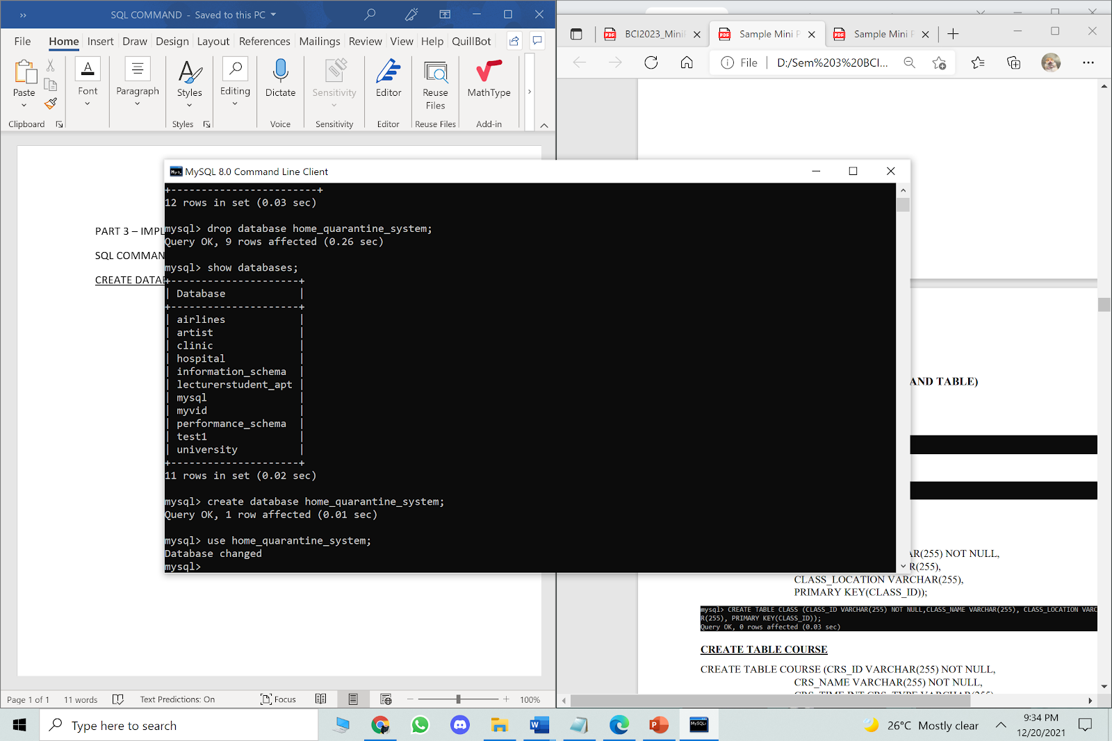

**USE DATABASE**

use home_quarantine_system;

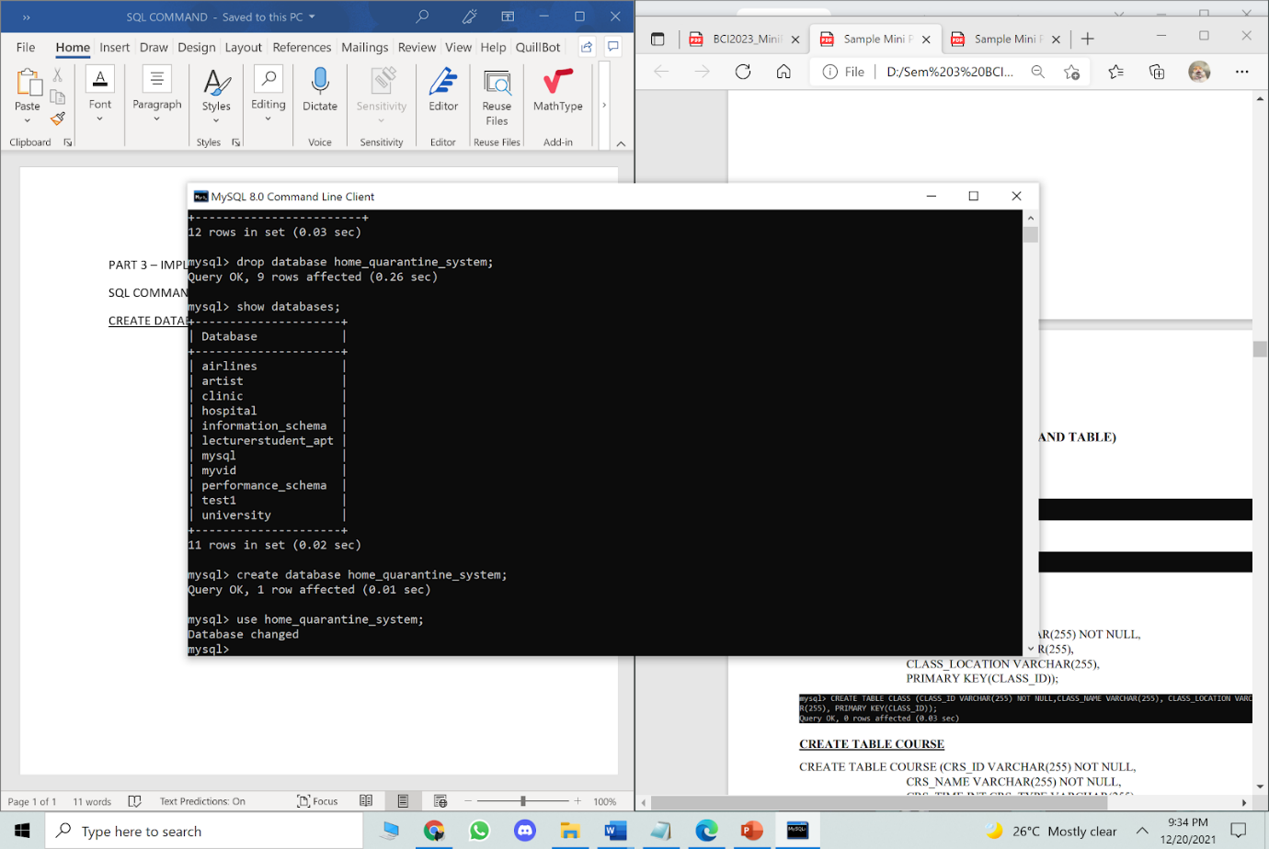

**CREATE TABLES**

**CREATE TABLE QUARANTINE**

create table home_quarantine_system.quarantine

(

address_referenceNo varchar(50) not null primary key,

quarantine_address varchar(50),

quarantine_postcode int,

quarantine_state varchar(20),

quarantine_district varchar(20)

);

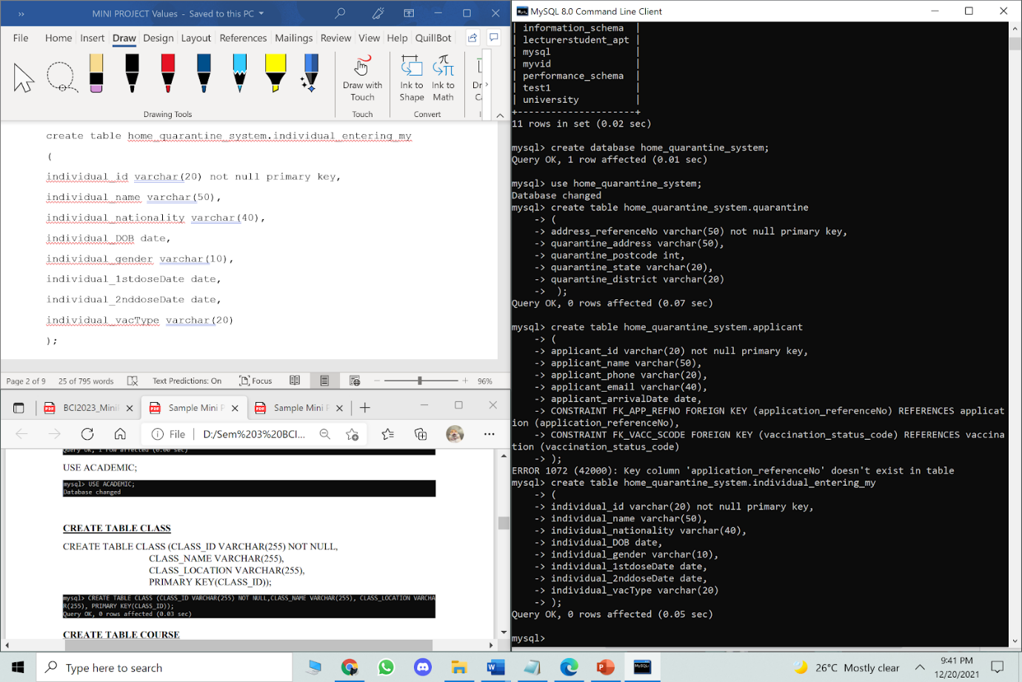

**CREATE TABLE INDIVIDUAL ENTERING MALAYSIA**

create table home_quarantine_system.individual_entering_my

(

individual_id varchar(20) not null primary key,

individual_name varchar(50),

individual_nationality varchar(40),

individual_DOB date,

individual_gender varchar(10),

individual_1stdoseDate date,

individual_2nddoseDate date,

individual_vacType varchar(20)

);



**CREATE TABLE TRANSPORTATION**

create table home_quarantine_system.transportation

(

 transport_code varchar(10) not null primary key,

 arrival_date date,

 arrival_time time

);

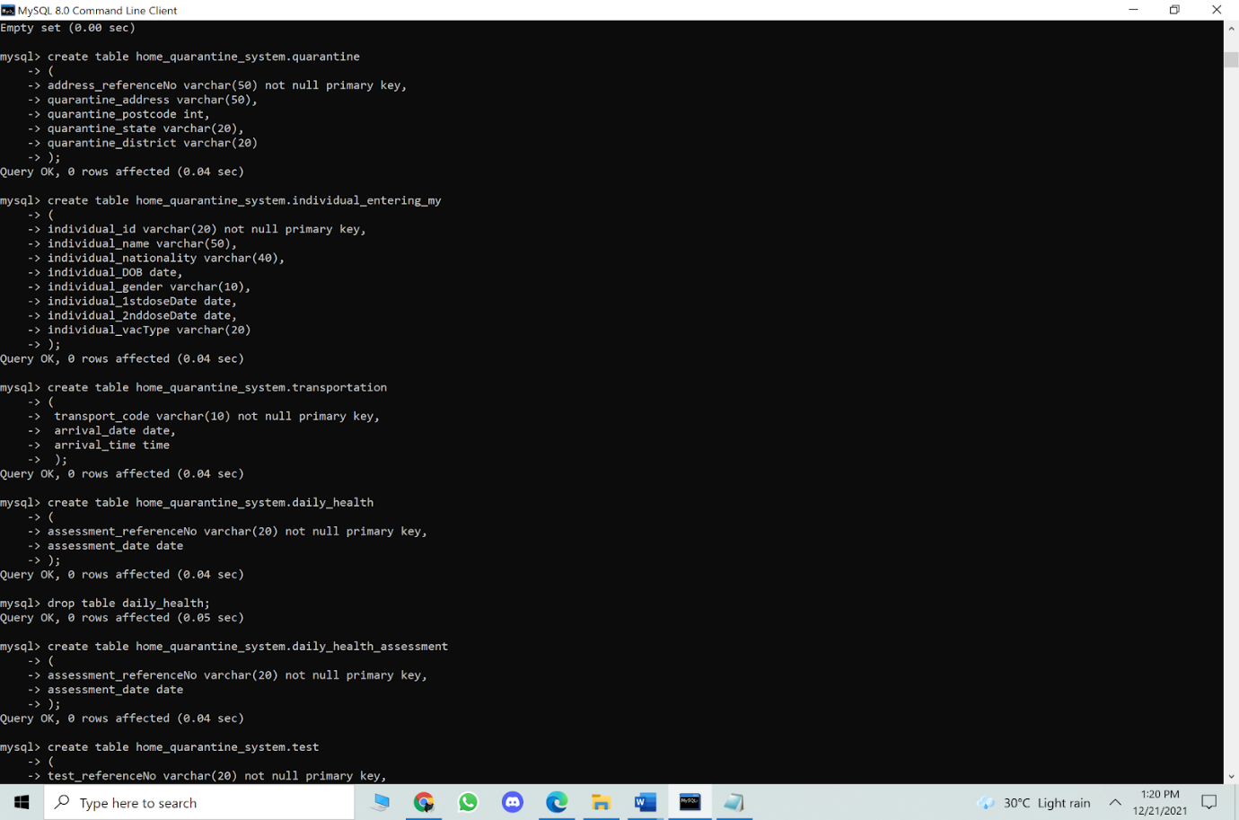

**CREATE TABLE DAILY HEALTH ASSESSMENT**

create table home_quarantine_system.daily_health_assessment

(

assessment_referenceNo varchar(20) not null primary key,

assessment_date date

);

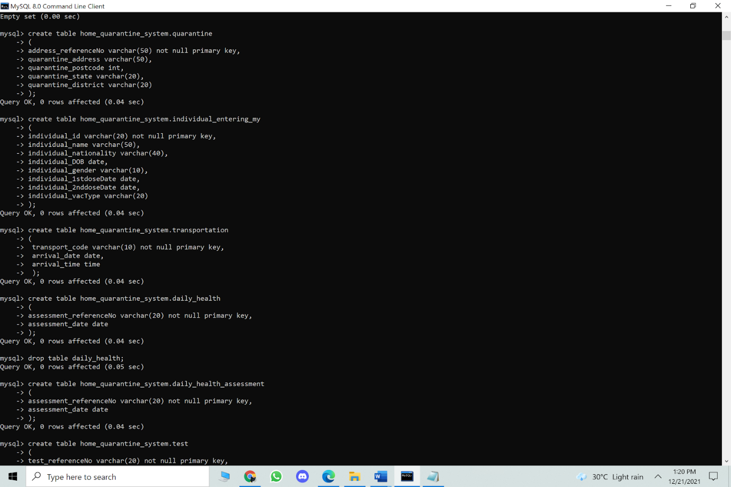

**CREATE TABLE TEST**

create table home_quarantine_system.test

(

test_referenceNo varchar(20) not null primary key,

test_date date

);

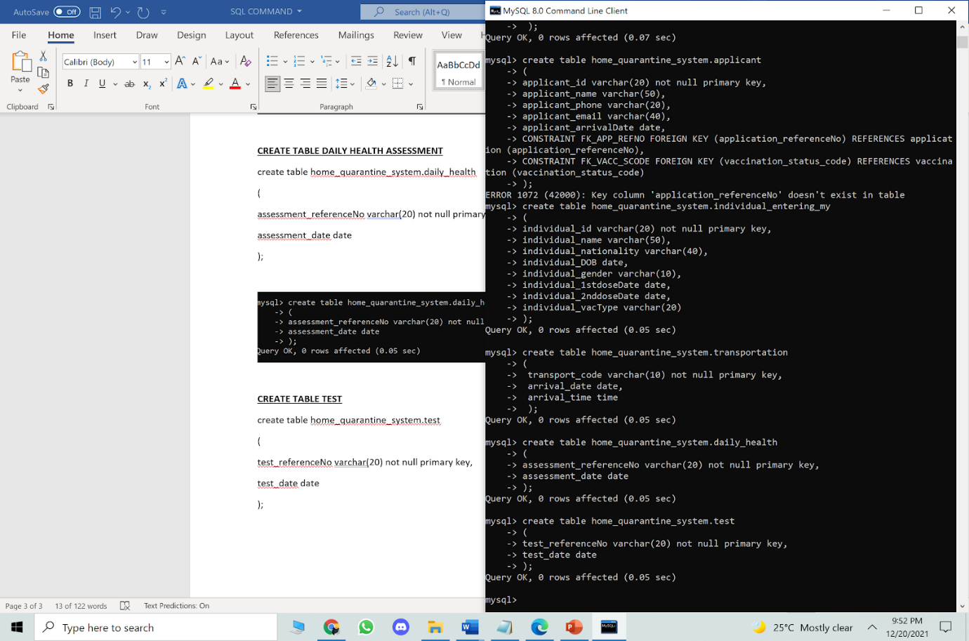

**CREATE TABLE  TRAVELLER**

create table home_quarantine_system.traveller

(

travel_departureCountry varchar(40) not null primary key,

travel_departureDate date,

travel_entryPoint varchar(30),

transport_code varchar(10),

assessment_referenceNo varchar(20),

test_referenceNo varchar(20),

individual_id varchar(20),

CONSTRAINT FK_TRANSPORT_CODE FOREIGN KEY(transport_code) REFERENCES transportation(transport_code),

CONSTRAINT FK_ASSESSMENT_REFNO FOREIGN KEY(assessment_referenceNo) REFERENCES daily_health_assessment(assessment_referenceNo),

CONSTRAINT FK_TEST_REFNO FOREIGN KEY(test_referenceNo) REFERENCES test(test_referenceNo),

CONSTRAINT FK_IND_ID FOREIGN KEY(individual_id) REFERENCES individual_entering_my(individual_id)

);

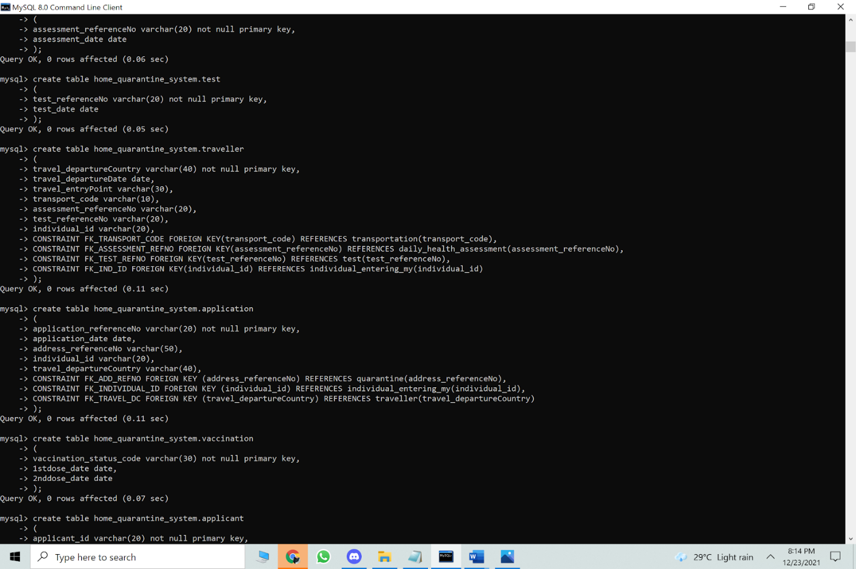

**CREATE TABLE APPLICATION**

create table home_quarantine_system.application

(

application_referenceNo varchar(20) not null primary key,

application_date date,

address_referenceNo varchar(50),

individual_id varchar(20),

travel_departureCountry varchar(40),

CONSTRAINT FK_ADD_REFNO FOREIGN KEY (address_referenceNo) REFERENCES quarantine(address_referenceNo),

CONSTRAINT FK_INDIVIDUAL_ID FOREIGN KEY (individual_id) REFERENCES individual_entering_my(individual_id),

CONSTRAINT FK_TRAVEL_DC FOREIGN KEY (travel_departureCountry) REFERENCES traveller(travel_departureCountry)

);

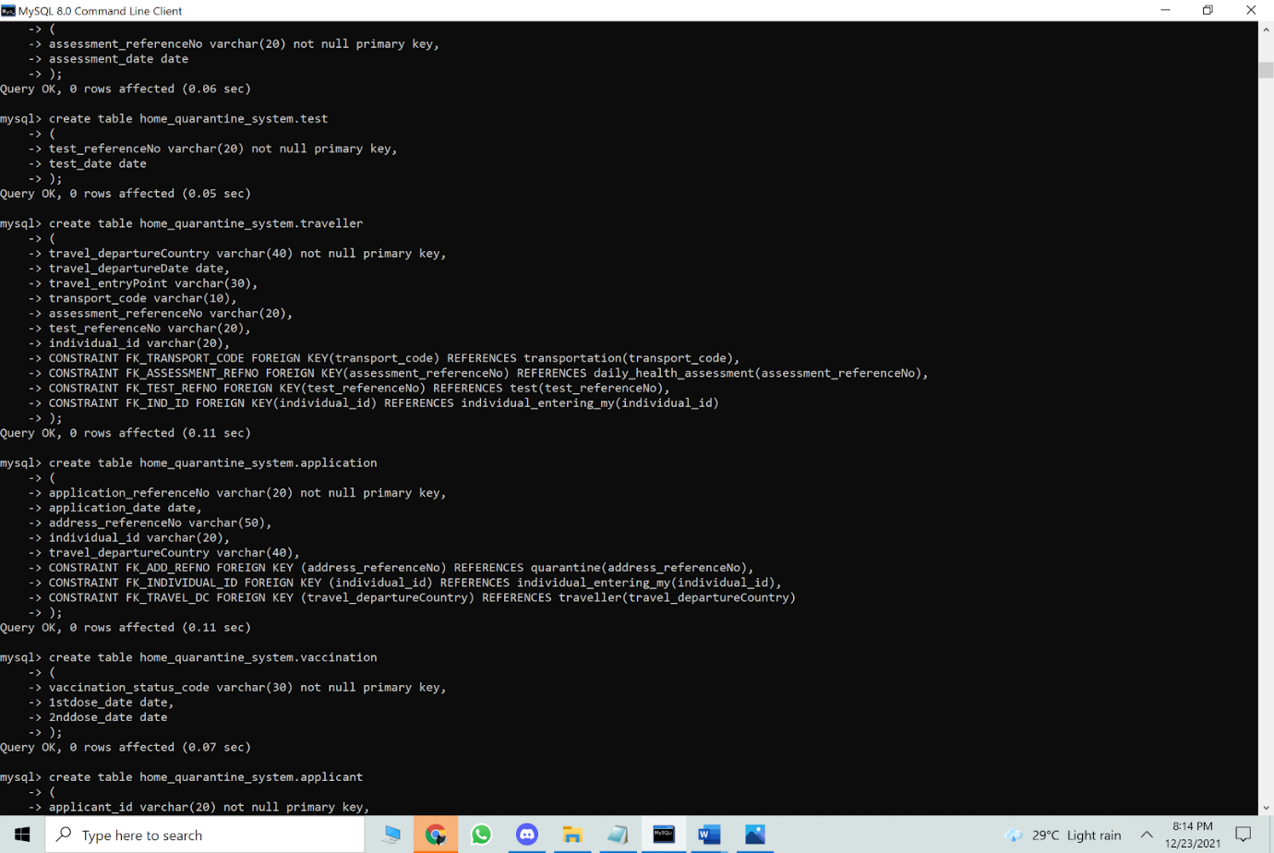

**CREATE TABLE VACCINATION**

create table home_quarantine_system.vaccination

(

vaccination_status_code varchar(30) not null primary key,

1stdose_date date,

2nddose_date date,

);

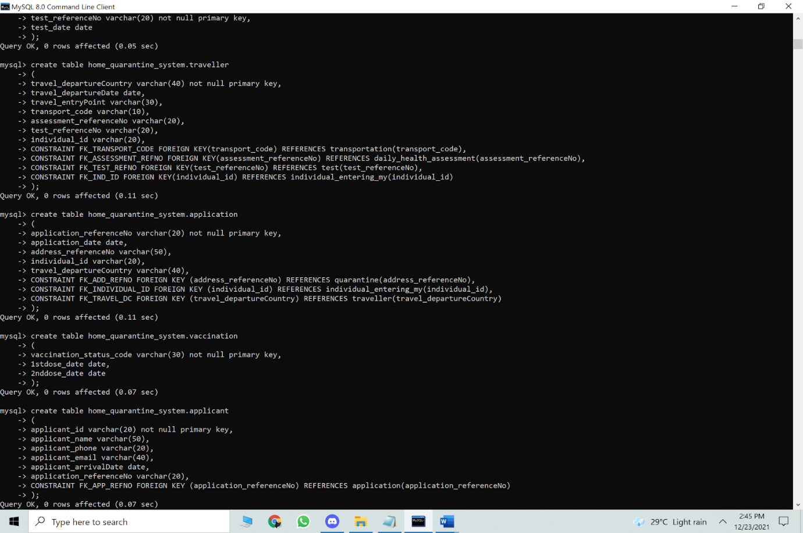

**CREATE TABLE APPLICANT**

create table home_quarantine_system.applicant

(

applicant_id varchar(20) not null primary key,

applicant_name varchar(50),

applicant_phone varchar(20),

applicant_email varchar(40),

applicant_arrivalDate date,

application_referenceNo varchar(20),

CONSTRAINT FK_APP_REFNO FOREIGN KEY (application_referenceNo) REFERENCES application(application_referenceNo)

);



**INSERT DATA**

**INSERT INTO QUARANTINE**

Insert into home_quarantine_system.quarantine values

('AD1001', 'Taman Suntex', 43200, 'Selangor', 'Cheras');

Insert into home_quarantine_system.quarantine values

('AD1002', 'Asas Jaya', 14100, 'Pulau Pinang', 'Simpang Ampat');

Insert into home_quarantine_system.quarantine values

('AD1003', 'Jalan Bukit Bintang', 55100, 'WP Kuala Lumpur', 'Bukit Bintang');

Insert into home_quarantine_system.quarantine values

('AD1004', 'Setia Ecohill', 43500, 'Selangor', 'Semenyih');

Insert into home_quarantine_system.quarantine values

 ('AD1005', 'Taman Sungai Isap Damai', 25150, 'Pahang', 'Kuantan');

Insert into home_quarantine_system.quarantine values

 ('AD1006', 'Telok Panglima Garang', 41200, 'Selangor', 'Banting');

Insert into home_quarantine_system.quarantine values

 ('AD1007', 'Taman Azam', 15400, 'Kelantan', 'Kota Bharu');

Insert into home_quarantine_system.quarantine values

('AD1008', 'Jalan P Ramlee', 10460, 'Georgetown', 'Pulau Pinang');

Insert into home_quarantine_system.quarantine values

('AD1009', 'Taman Sungai Rambai Putra', 77400, 'Sungai Rambai', 'Melaka');

Insert into home_quarantine_system.quarantine values

('AD1010', 'Jalan Bukit Meru', 30020, 'Perak', 'Ipoh');

Insert into home_quarantine_system.quarantine values

 ('AD1011', 'Kampung Pisang', 33000, 'Perak', 'Kuala Kangsar');

Insert into home_quarantine_system.quarantine values

 ('AD1012', 'Kampung Mawar', 33000, 'Perak', 'Kuala Kangsar');

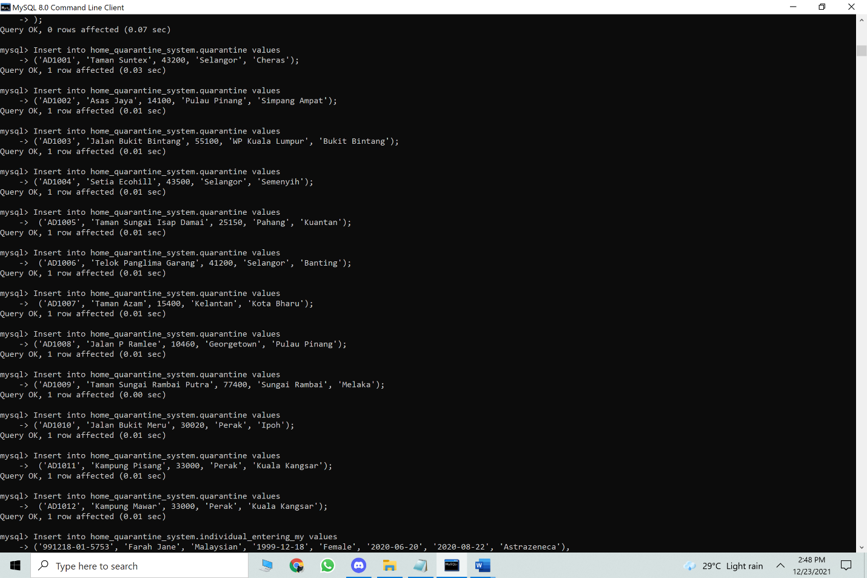

**INSERT INTO INDIVIDUAL ENTERING MALAYSIA**

Insert into home_quarantine_system.individual_entering_my values

('991218-01-5753', 'Farah Jane', '1999-12-18', 'Female', '2020-06-20', '2020-08-22', 'Astrazeneca', 'Malaysian'),

('781013-04-7658', 'Akmal Naufal', '1978-10-13', 'Male', '2020-07-11', '2020-09-12', 'Astrazeneca', 'Malaysian'),

('761101-10-0012', 'Ahmad bin Isa', '1976-11-01', 'Male', '2020-05-30', '2020-08-01', 'Astrazeneca', 'Malaysian'),

('660521-14-0987', 'Sofiah Binti Kamaruddin', '1966-05-21', 'Female', '2020-05-31', '2020-08-02', 'Astrazeneca', 'Malaysian'),

('690621-02-4232', 'Amiruddin bin Ali', '1969-06-21','Male', '2020-07-12', '2020-09-13', 'Astrazeneca', 'Malaysian'),

('700325-10-6754', 'Michael Lee', '1970-03-25', 'Male', '2020-09-05', '2020-09-26', 'Pfizer', 'Malaysian'),

('710809-06-5543', 'Tan Ming Hui','1971-08-09', 'Female', '2020-09-04', '2020-09-25', 'Sinovac', 'Malaysian'),

('801228-14-0967', 'Lim Yuqi', '1980-12-28', 'Female', '2020-06-28', '2020-07-19', 'Sinovac','Malaysian'),

('890709-06-6890', 'Saraswati',  '1989-09-07', 'Female', '2020-09-05', '2020-09-26', 'Pfizer', 'Non-Malaysian'),

('891117-04-8976', 'Prisha',  '1989-11-17', 'Female', '2020-11-09', null, 'Johnson & Johnson', 'Non-Malaysian'),

('910914-05-1254', 'Krishna', '1991-09-14', 'Male', '2020-11-01', '2020-11-22', 'Pfizer', 'Malaysian'),

('951017-10-8076', 'Vinoth', '1995-10-17', 'Male', '2020-06-15', '2020-07-06', 'Moderna', 'Non-Malaysian')

;

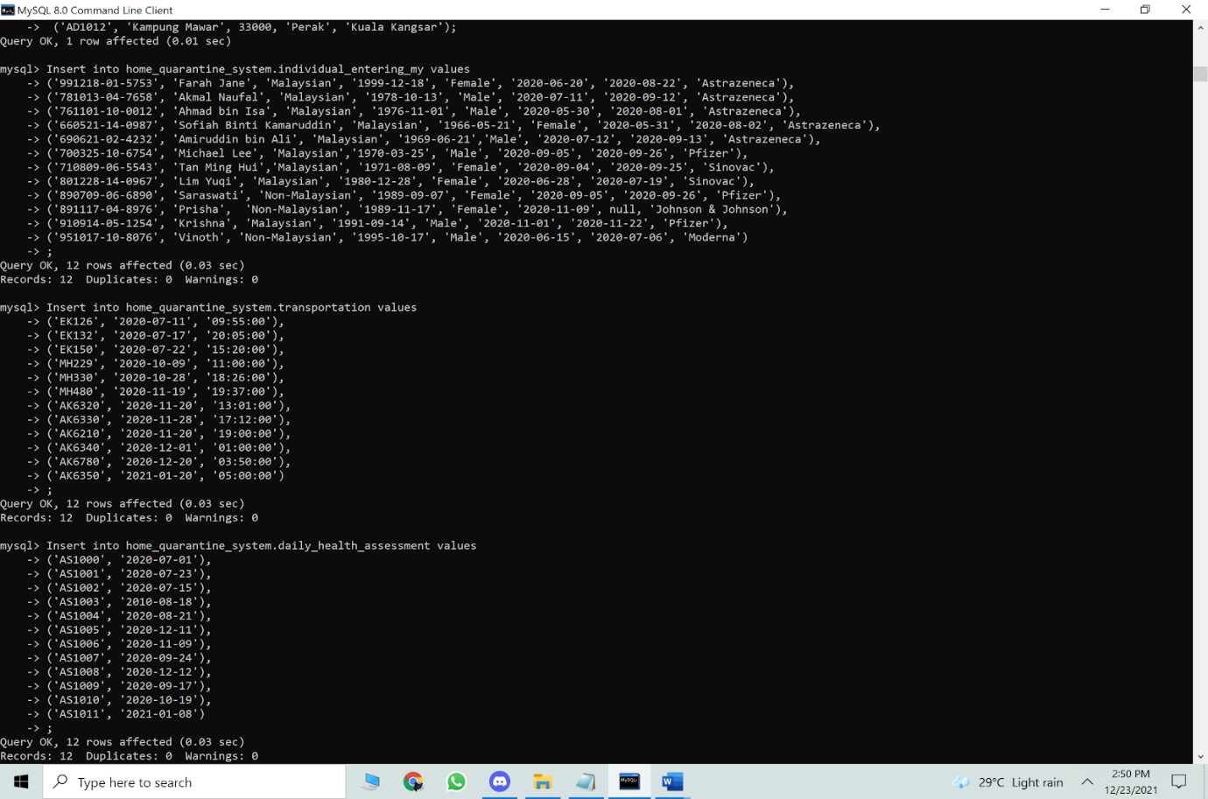

**INSERT INTO TRANSPORTATION**

Insert into home_quarantine_system.transportation values

('EK126', '2020-07-11', '09:55:00'),

('EK132', '2020-07-17', '20:05:00'),

('EK150', '2020-07-22', '15:20:00'),

('MH229', '2020-10-09', '11:00:00'),

('MH330', '2020-10-28', '18:26:00'),

('MH480', '2020-11-19', '19:37:00'),

('AK6320', '2020-11-20', '13:01:00'),

('AK6330', '2020-11-28', '17:12:00'),

('AK6210', '2020-11-20', '19:00:00'),

('AK6340', '2020-12-01', '01:00:00'),

('AK6780', '2020-12-20', '03:50:00'),

('AK6350', '2021-01-20', '05:00:00')

;

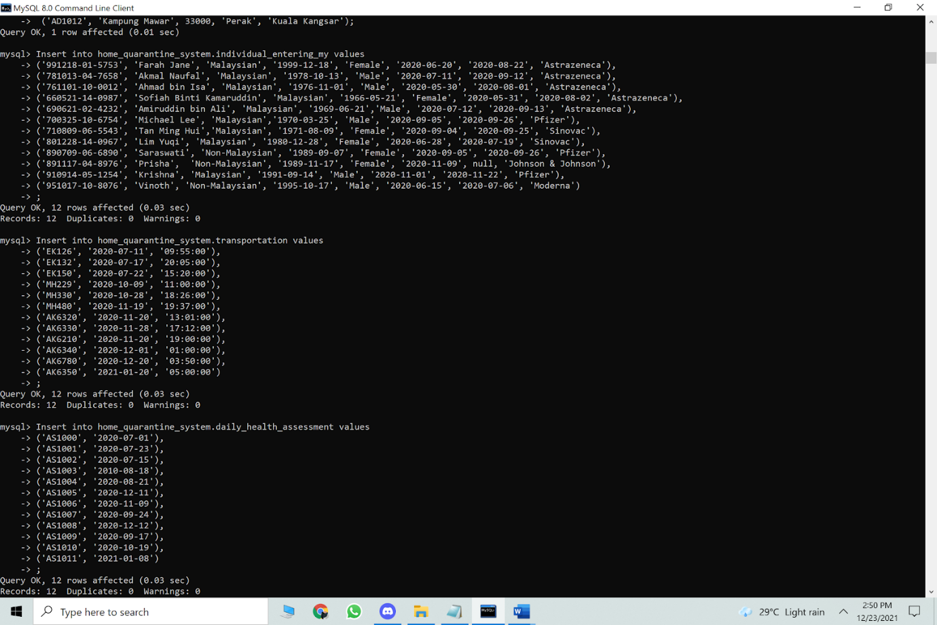

**INSERT INTO DAILY HEALTH ASSESSMENT**

Insert into home_quarantine_system.daily_health_assessment values

('AS1000', '2020-07-01'),

('AS1001', '2020-07-23'),

('AS1002', '2020-07-15'),

('AS1003', '2010-08-18'),

('AS1004', '2020-08-21'),

('AS1005', '2020-12-11'),

('AS1006', '2020-11-09'),

('AS1007', '2020-09-24'),

('AS1008', '2020-12-12'),

('AS1009', '2020-09-17'),

('AS1010', '2020-10-19'),

('AS1011', '2021-01-08')

;



**INSERT INTO TEST**

Insert into home_quarantine_system.test values

('TS1001', '2020-09-18'),

('TS1002', '2020-10-19'),

('TS1003', '2020-10-30'),

('TS1004', '2020-09-18'),

('TS1005', '2020-08-07'),

('TS1006', '2020-08-11'),

('TS1007', '2020-08-19'),

('TS1008', '2020-10-13'),

('TS1009', '2020-11-18'),

('TS1010', '2020-12-30'),

('TS1011', '2020-12-25'),

('TS1012', '2021-01-01')

;

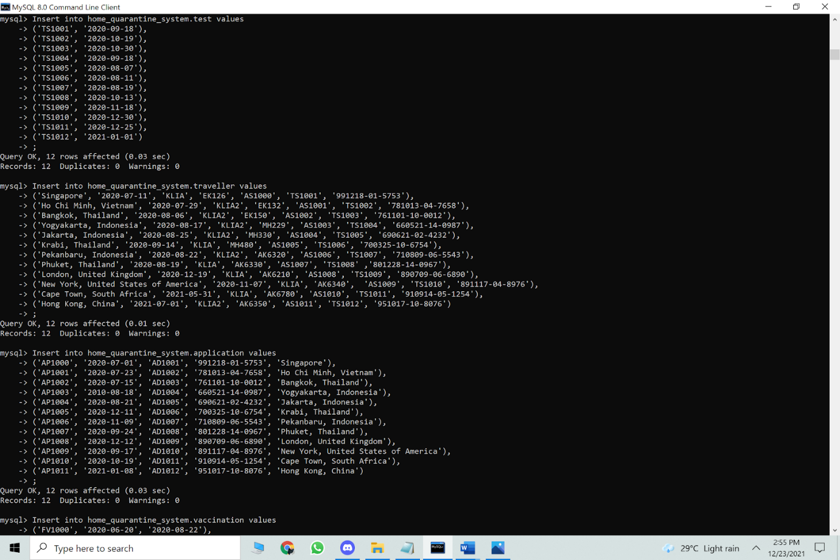

**INSERT INTO TRAVELLER**

Insert into home_quarantine_system.traveller values

('Singapore', '2020-07-11', 'KLIA', 'EK126', 'AS1000', 'TS1001', '991218-01-5753'),

('Ho Chi Minh, Vietnam', '2020-07-29', 'KLIA2', 'EK132', 'AS1001', 'TS1002', '781013-04-7658'),

('Bangkok, Thailand', '2020-08-06', 'KLIA2', 'EK150', 'AS1002', 'TS1003', '761101-10-0012'),

('Yogyakarta, Indonesia', '2020-08-17', 'KLIA2', 'MH229', 'AS1003', 'TS1004', '660521-14-0987'),

('Jakarta, Indonesia', '2020-08-25', 'KLIA2', 'MH330', 'AS1004', 'TS1005', '690621-02-4232'),

('Krabi, Thailand', '2020-09-14', 'KLIA', 'MH480', 'AS1005', 'TS1006', '700325-10-6754'),

('Pekanbaru, Indonesia', '2020-08-22', 'KLIA2', 'AK6320', 'AS1006', 'TS1007', '710809-06-5543'),

('Phuket, Thailand', '2020-08-19', 'KLIA', 'AK6330', 'AS1007', 'TS1008' ,'801228-14-0967'),

('London, United Kingdom', '2020-12-19', 'KLIA', 'AK6210', 'AS1008', 'TS1009', '890709-06-6890'),

('New York, United States of America', '2020-11-07', 'KLIA', 'AK6340',  'AS1009', 'TS1010', '891117-04-8976'),

('Cape Town, South Africa', '2021-05-31', 'KLIA', 'AK6780', 'AS1010', 'TS1011', '910914-05-1254'),

('Hong Kong, China', '2021-07-01', 'KLIA2', 'AK6350', 'AS1011', 'TS1012', '951017-10-8076')

;

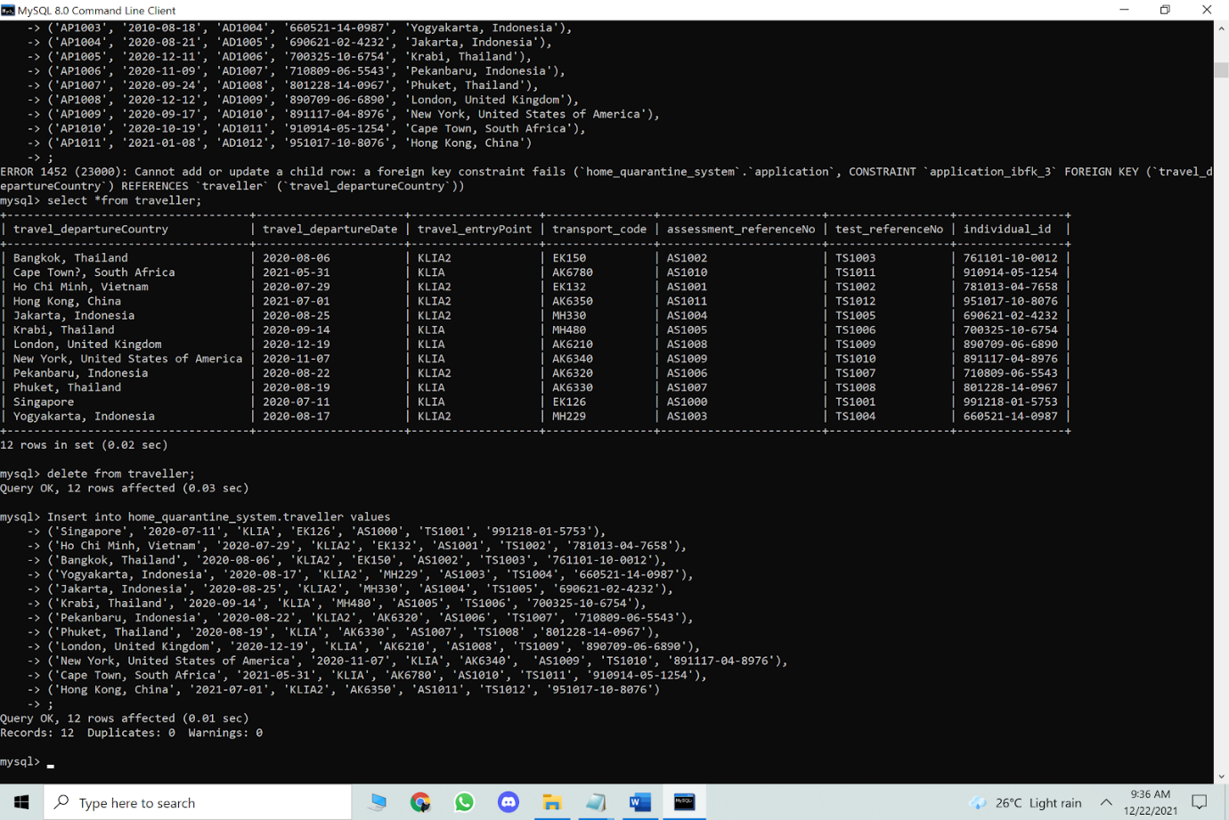

**INSERT INTO APPLICATION**

Insert into home_quarantine_system.application values

('AP1000', '2020-07-01', 'AD1001', '991218-01-5753', 'Singapore'),

('AP1001', '2020-07-23', 'AD1002', '781013-04-7658', 'Ho Chi Minh, Vietnam'),

('AP1002', '2020-07-15', 'AD1003', '761101-10-0012', 'Bangkok, Thailand'),

('AP1003', '2010-08-18', 'AD1004', '660521-14-0987', 'Yogyakarta, Indonesia'),

('AP1004', '2020-08-21', 'AD1005', '690621-02-4232', 'Jakarta, Indonesia'),

('AP1005', '2020-12-11', 'AD1006', '700325-10-6754', 'Krabi, Thailand'),

('AP1006', '2020-11-09', 'AD1007', '710809-06-5543', 'Pekanbaru, Indonesia'),

('AP1007', '2020-09-24', 'AD1008', '801228-14-0967', 'Phuket, Thailand'),

('AP1008', '2020-12-12', 'AD1009', '890709-06-6890', 'London, United Kingdom'),

('AP1009', '2020-09-17', 'AD1010', '891117-04-8976', 'New York, United States of America'),

('AP1010', '2020-10-19', 'AD1011', '910914-05-1254', 'Cape Town, South Africa'),

('AP1011', '2021-01-08', 'AD1012', '951017-10-8076', 'Hong Kong, China')

;

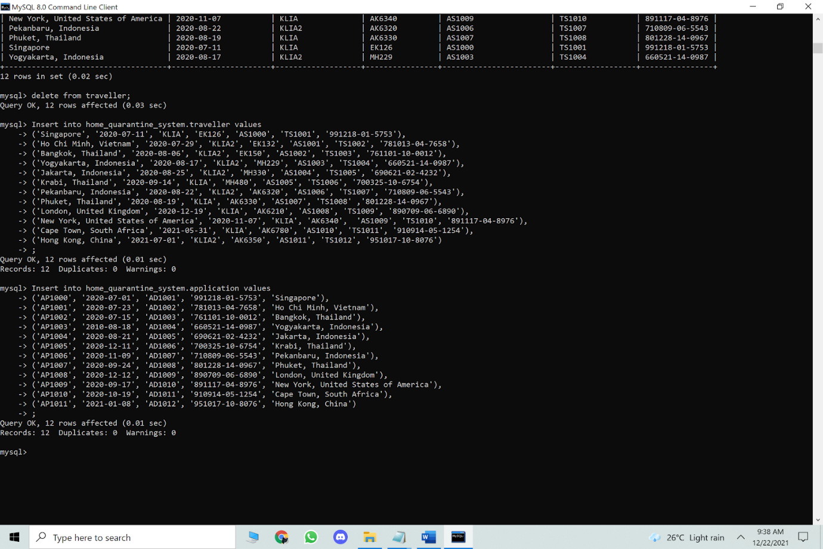

**INSERT INTO VACCINATION**

Insert into home_quarantine_system.vaccination values

('FV1000', '2020-06-20', '2020-08-22'),

('FV1001', '2020-07-11', '2020-09-12'),

('FV1002', '2020-05-30', '2020-08-01'),

('FV1003', '2020-09-09', '2020-11-11'),

('FV1004', '2020-06-06', '2020-06-22'),

('FV1005', '2020-02-14', '2020-03-07'),

('FV1006', '2020-06-30', '2020-07-21'),

('FV1007', '2020-07-05', '2020-07-26'),

('FV1008', '2020-10-20', '2020-11-10'),

('FV1009', '2020-10-19', '2020-11-09'),

('FV1010', '2020-09-04', '2020-09-25'),

('FV1011', '2020-11-01', '2020-11-22')

;

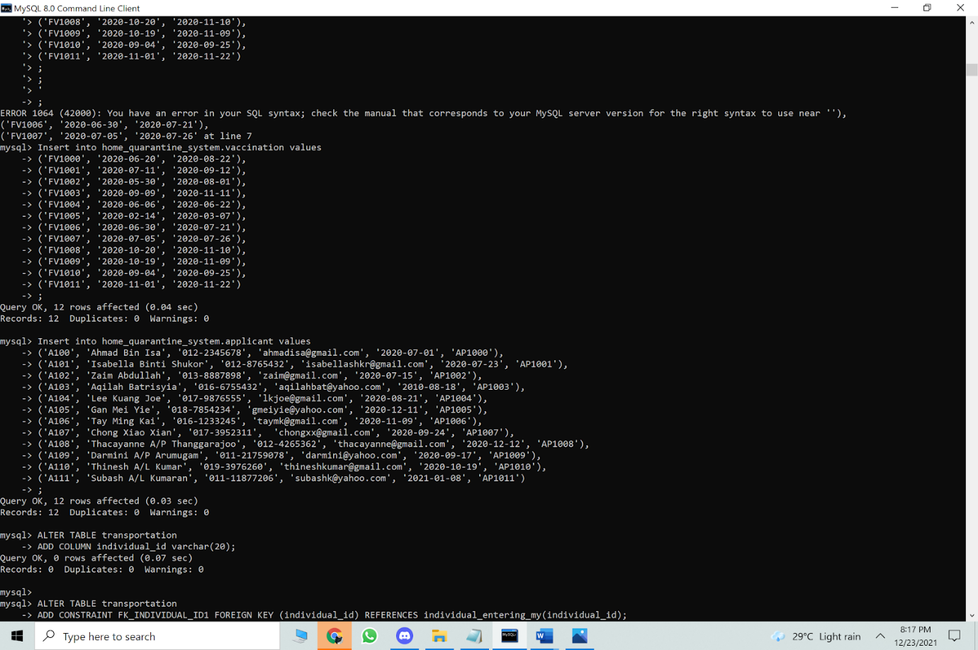

**INSERT INTO APPLICANT**

Insert into home_quarantine_system.applicant values

('A100', 'Ahmad Bin Isa', '012-2345678', 'ahmadisa@gmail.com', '2020-07-01', 'AP1000'),

('A101', 'Isabella Binti Shukor', '012-8765432', 'isabellashkr@gmail.com', '2020-07-23', 'AP1001'),

('A102', 'Zaim Abdullah', '013-8887898', 'zaim@gmail.com', '2020-07-15', 'AP1002'),

('A103', 'Aqilah Batrisyia', '016-6755432', 'aqilahbat@yahoo.com', '2010-08-18', 'AP1003'),

('A104', 'Lee Kuang Joe', '017-9876555', 'lkjoe@gmail.com', '2020-08-21', 'AP1004'),

('A105', 'Gan Mei Yie', '018-7854234', 'gmeiyie@yahoo.com', '2020-12-11', 'AP1005'),

('A106', 'Tay Ming Kai', '016-1233245', 'taymk@gmail.com', '2020-11-09', 'AP1006'),

('A107', 'Chong Xiao Xian', '017-3952311', 'chongxx@gmail.com', '2020-09-24', 'AP1007'),

('A108', 'Thacayanne A/P Thanggarajoo', '012-4265362', 'thacayanne@gmail.com', '2020-12-12', 'AP1008'),

('A109', 'Darmini A/P Arumugam', '011-21759078', 'darmini@yahoo.com', '2020-09-17', 'AP1009'),

('A110', 'Thinesh A/L Kumar', '019-3976260', 'thineshkumar@gmail.com', '2020-10-19', 'AP1010'),

('A111', 'Subash A/L Kumaran', '011-11877206', 'subashk@yahoo.com', '2021-01-08', 'AP1011')

;



Insert into home_quarantine_system.applicant values

('A100', 'Ahmad Bin Isa', '012-2345678', 'ahmadisa@gmail.com', '2020-07-01', 'AP1000');

Insert into home_quarantine_system.vaccination values

('FV1000', '2020-06-20', '2020-08-22');

**ALTERING THE TABLES**

**ALTER TABLE TRANSPORTATION**

ALTER TABLE transportation

ADD COLUMN individual_id varchar(20);

ALTER TABLE transportation

ADD CONSTRAINT FK_INDIVIDUAL_ID1 FOREIGN KEY (individual_id) REFERENCES individual_entering_my(individual_id);

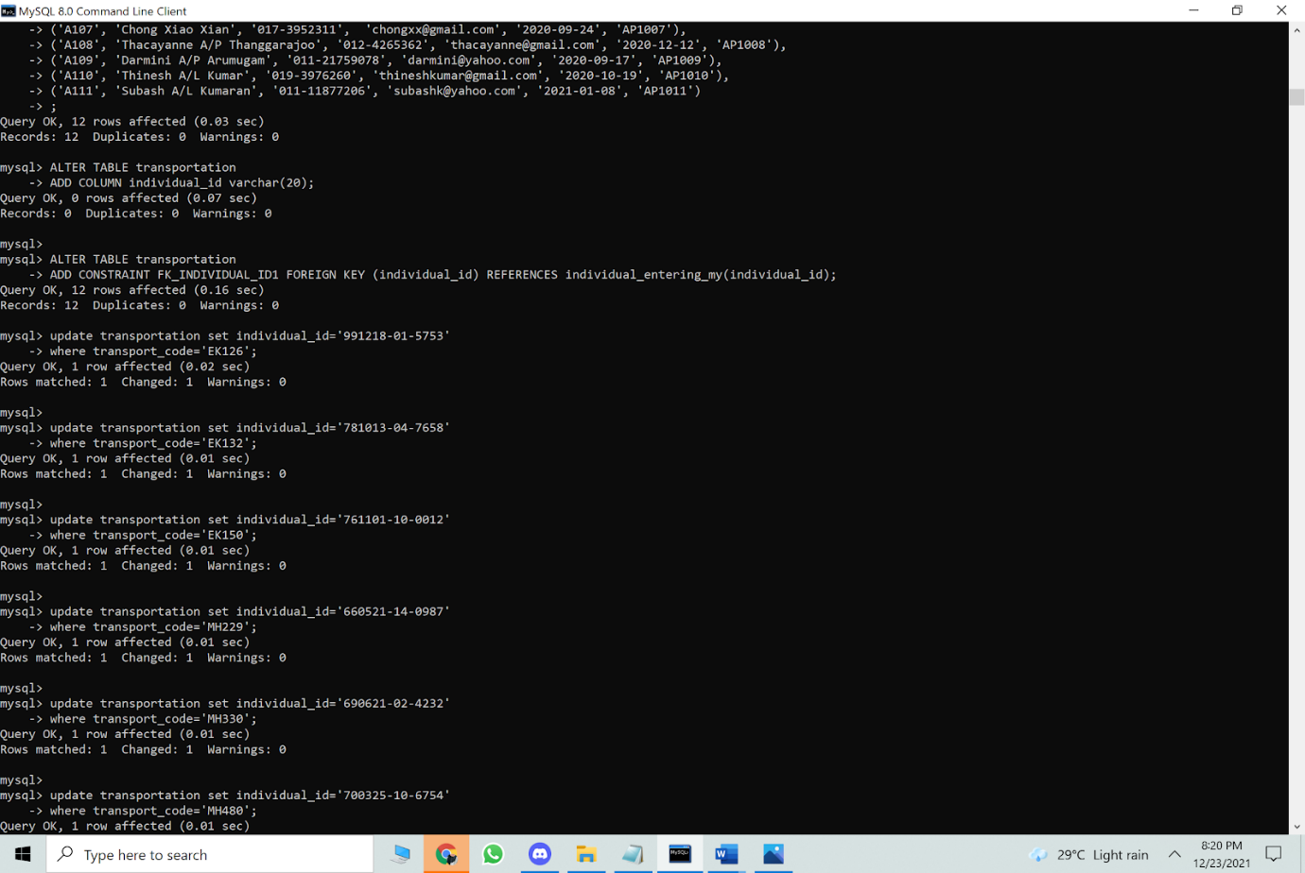

**ALTER TABLE DAILY_HEALTH_ASSESSMENT**

ALTER TABLE daily_health_assessment

ADD COLUMN individual_id varchar(20);

ALTER TABLE daily_health_assessment

ADD CONSTRAINT FK_INDIVIDUAL_ID2 FOREIGN KEY (individual_id) REFERENCES individual_entering_my(individual_id);

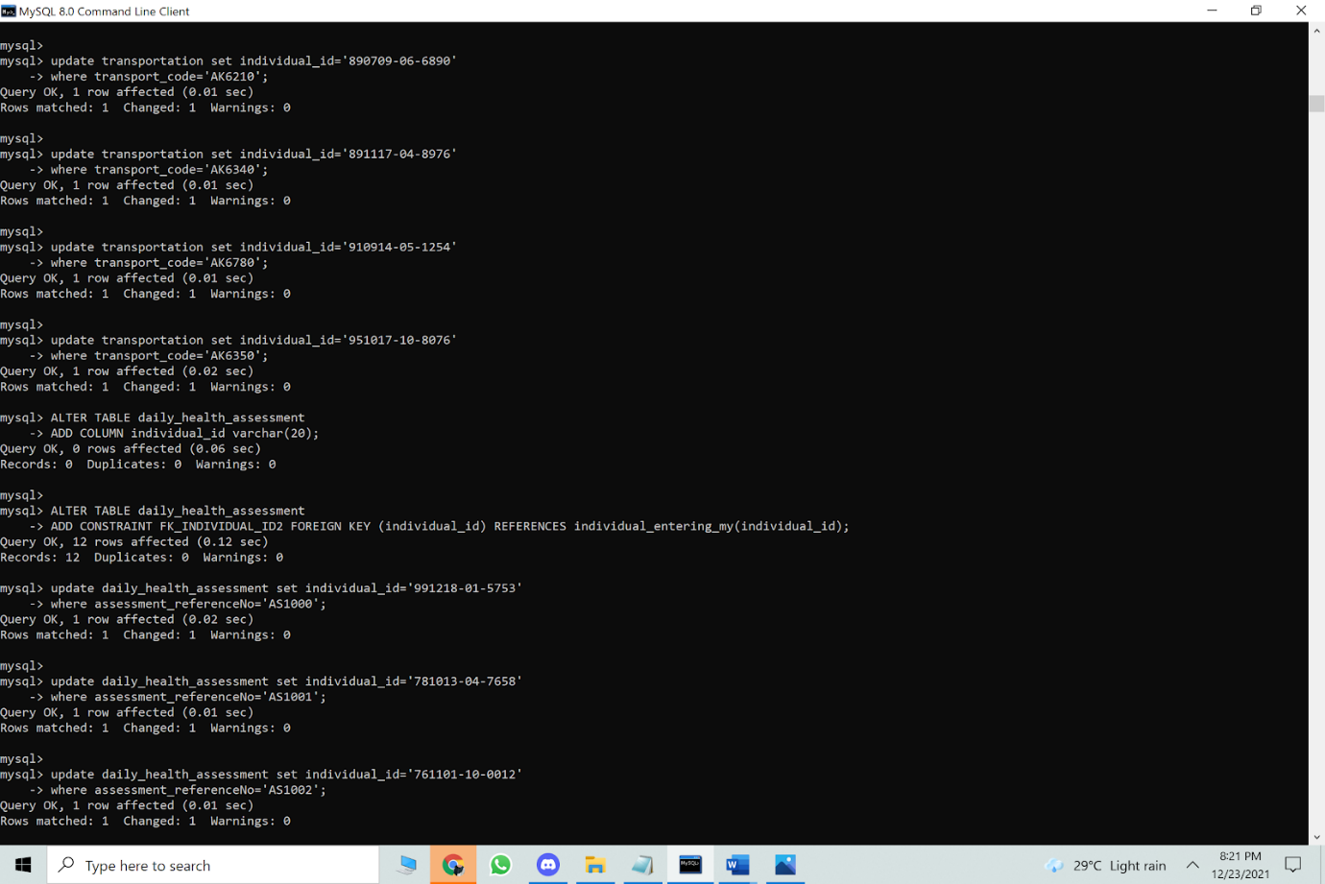

**ALTER TABLE TEST**

ALTER TABLE test

ADD COLUMN individual_id varchar(20);

ALTER TABLE test

ADD CONSTRAINT FK_INDIVIDUAL_ID3 FOREIGN KEY (individual_id) REFERENCES individual_entering_my(individual_id);

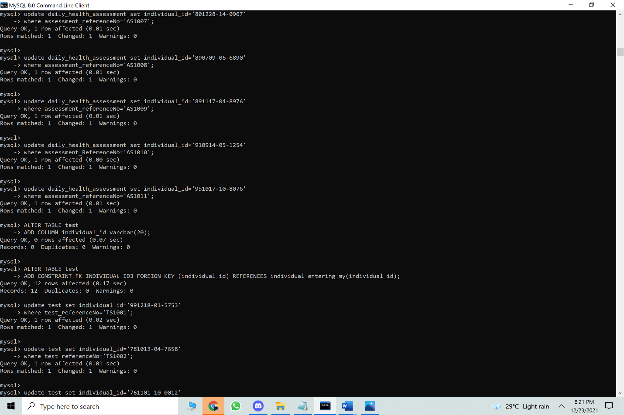

ALTER TABLE TEST

ADD COLUMN test_result varchar(10);

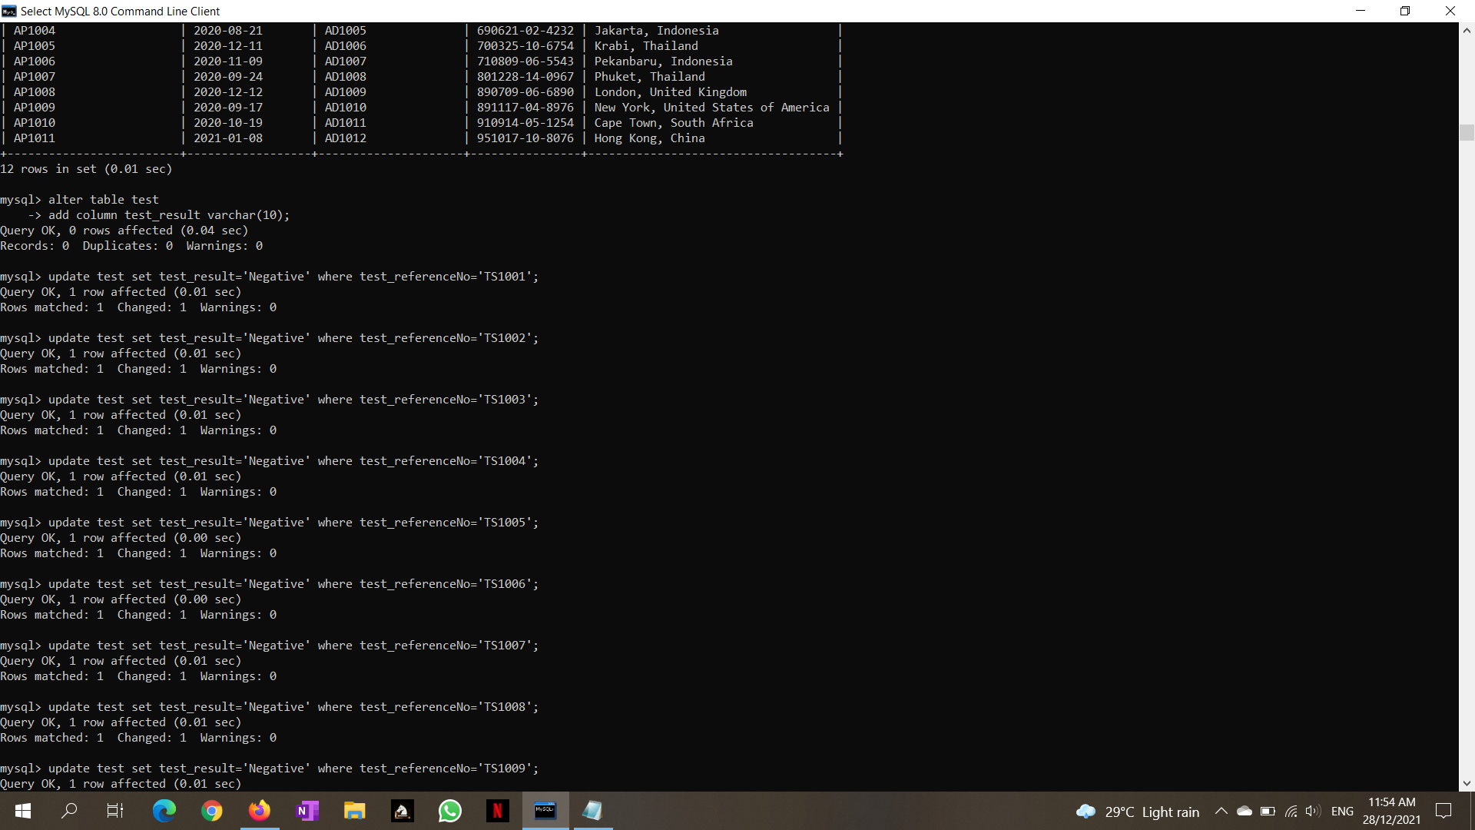

**ALTER TABLE APPLICANT**

ALTER TABLE applicant

ADD COLUMN vaccination_status_code varchar(20);

ALTER TABLE applicant

ADD CONSTRAINT FK_VACC_SCODE FOREIGN KEY (vaccination_status_code) REFERENCES vaccination(vaccination_status_code);

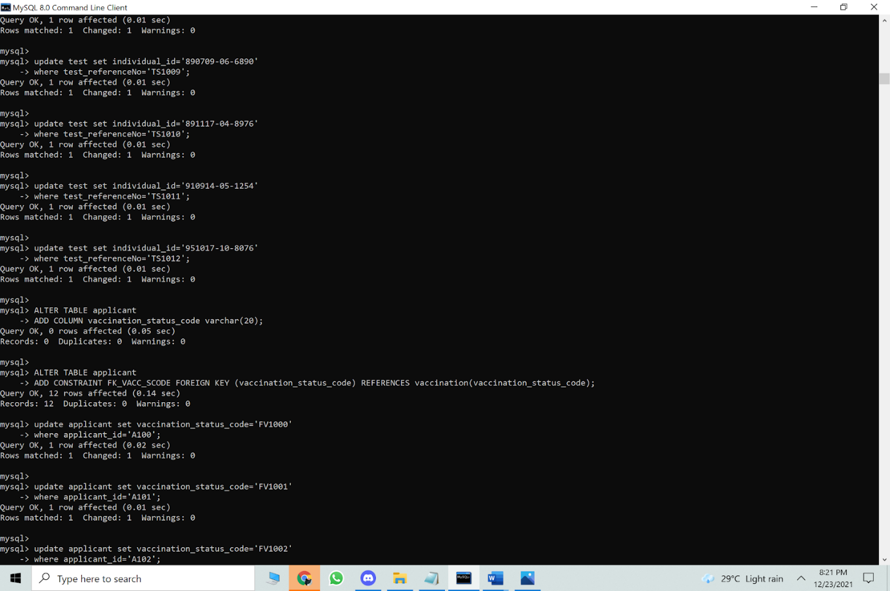

**ALTER TABLE VACCINATION**

ALTER TABLE vaccination

ADD COLUMN applicant_id varchar(20);

ALTER TABLE vaccination

ADD CONSTRAINT FK_APPLICANT_ID FOREIGN KEY (applicant_id) REFERENCES applicant(applicant_id);

ALTER TABLE VACCINATION

ADD COLUMN individual_id in vaccination;

ALTER TABLE VACCINATION

ADD FOREIGN KEY (individual_id) REFERENCES individual_entering_my(individual_id);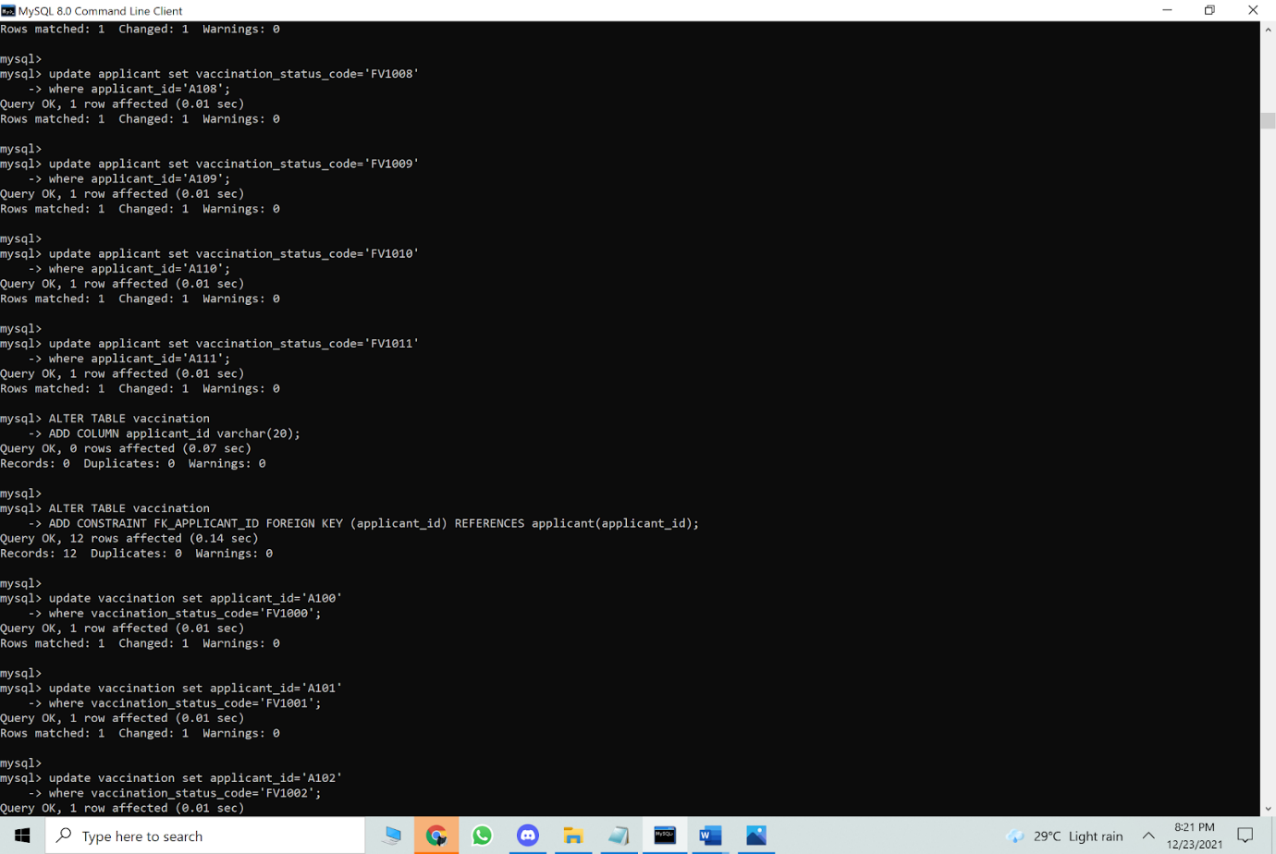

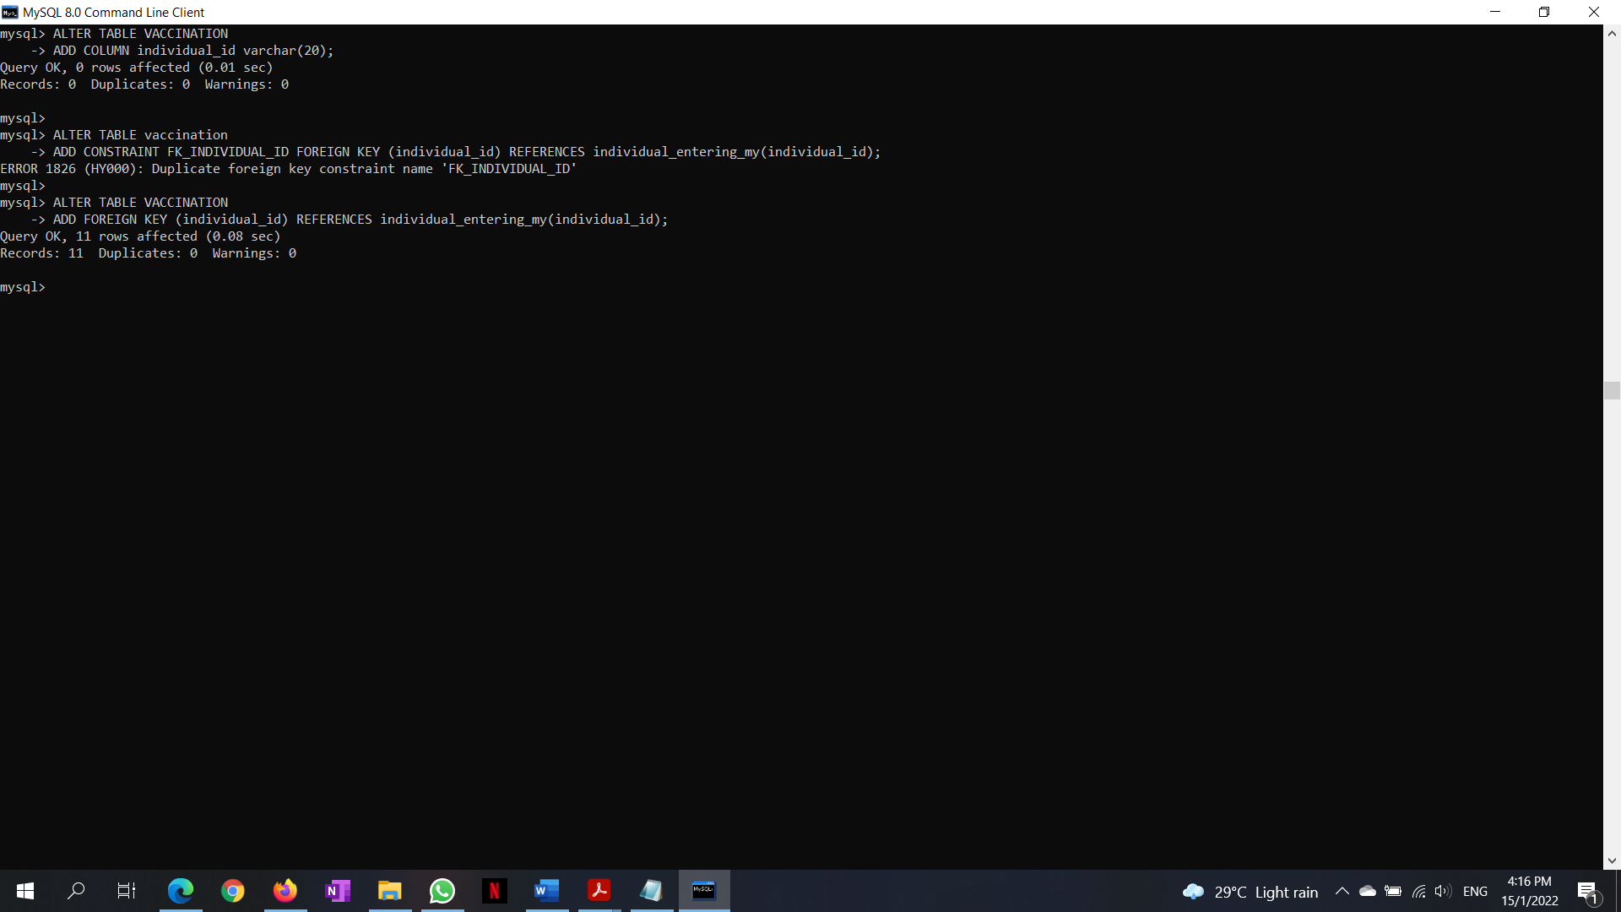

  
**DROP DATABASE**

drop database home_quarantine_system;

show databases;

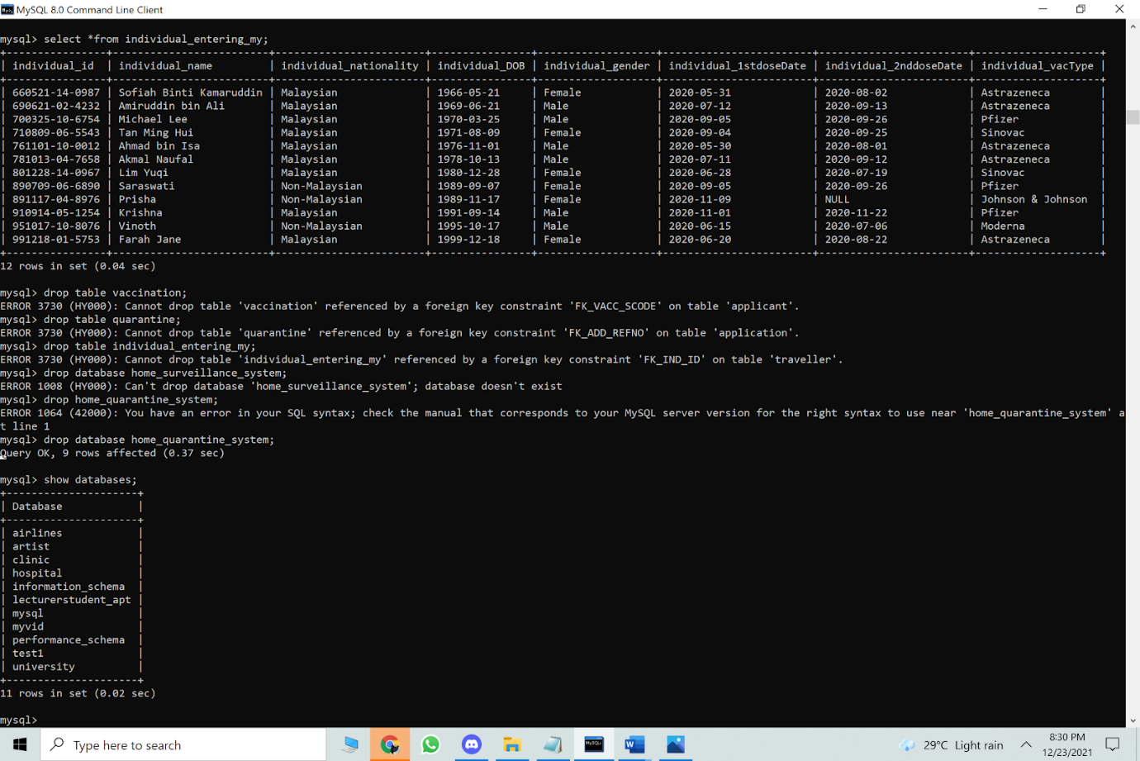

**DROP TABLE**

drop table transportation;

show tables;

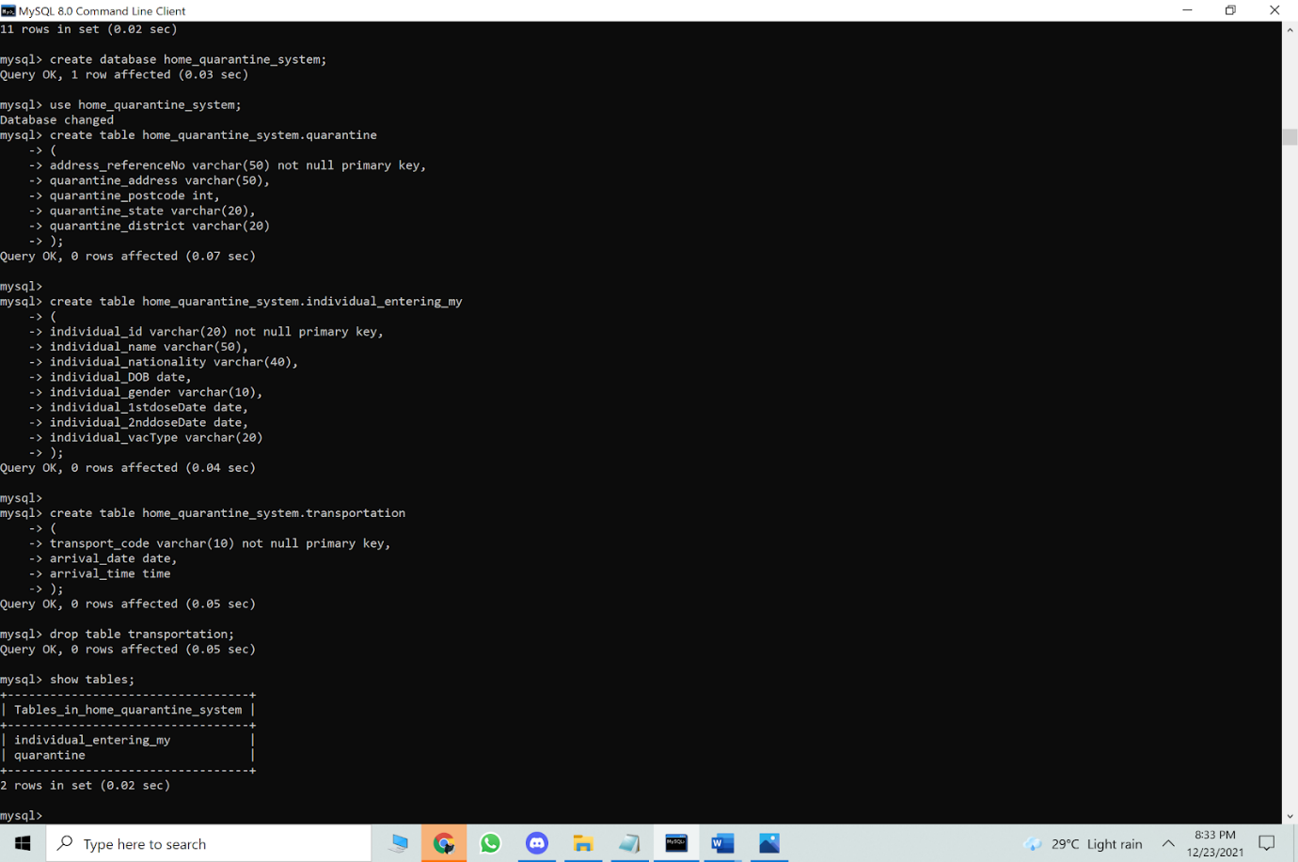

**6.0 Data Manipulation Language (DML)**

**UPDATE**

update transportation set individual_id='991218-01-5753'

where transport_code='EK126';

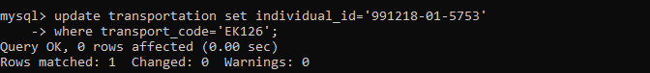

update transportation set individual_id='781013-04-7658'

where transport_code='EK132';

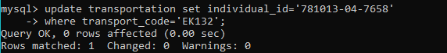

update transportation set individual_id='761101-10-0012'

where transport_code='EK150';

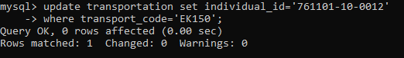

update transportation set individual_id='660521-14-0987'

where transport_code='MH229';

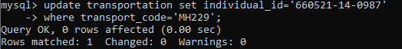

update transportation set individual_id='690621-02-4232'

where transport_code='MH330';

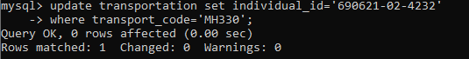

update transportation set individual_id='700325-10-6754'

where transport_code='MH480';

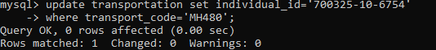

update transportation set individual_id='710809-06-5543'

where transport_code='AK6320';

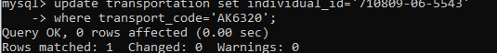

update transportation set individual_id='890709-06-6890'

where transport_code='AK6210';

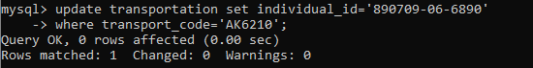

update transportation set individual_id='891117-04-8976'

where transport_code='AK6340';

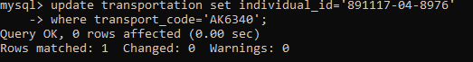

update transportation set individual_id='910914-05-1254'

where transport_code='AK6780';

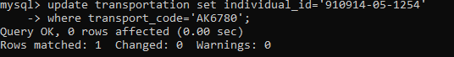

update transportation set individual_id='951017-10-8076'

where transport_code='AK6350';

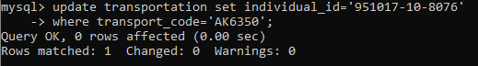

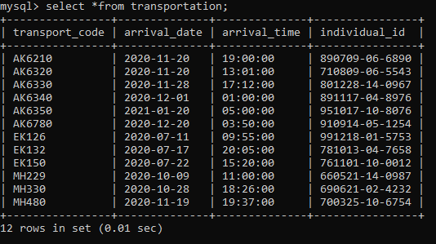

update daily_health_assessment set individual_id='991218-01-5753'

where assessment_referenceNo='AS1000';

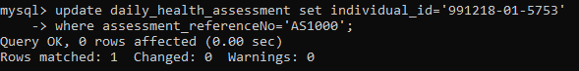

update daily_health_assessment set individual_id='781013-04-7658'

where assessment_referenceNo='AS1001';

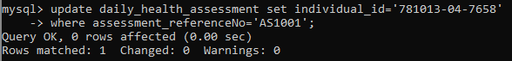

update daily_health_assessment set individual_id='761101-10-0012'

where assessment_referenceNo='AS1002';

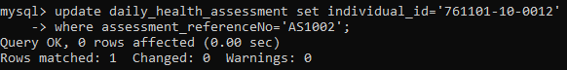

update daily_health_assessment set individual_id='660521-14-0987'

where assessment_referenceNo='AS1003';

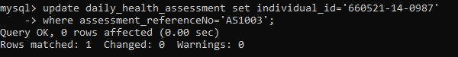

update daily_health_assessment set individual_id='690621-02-4232'

where assessment_referenceNo='AS1004';

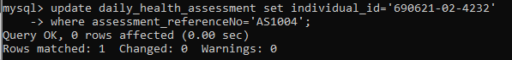

update daily_health_assessment set individual_id='700325-10-6754'

where assessment_referenceNo='AS1005';

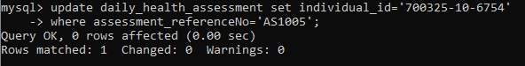

update daily_health_assessment set individual_id='710809-06-5543'

where assessment_referenceNo='AS1006';

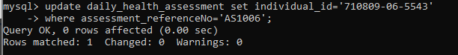

update daily_health_assessment set individual_id='801228-14-0967'

where assessment_referenceNo='AS1007';

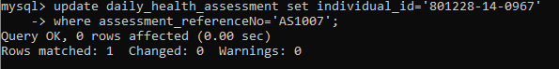

update daily_health_assessment set individual_id='890709-06-6890'

where assessment_referenceNo='AS1008';

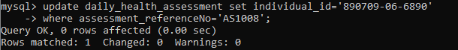

update daily_health_assessment set individual_id='891117-04-8976'

where assessment_referenceNo='AS1009';

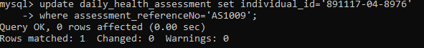

update daily_health_assessment set individual_id='910914-05-1254'

where assessment_ReferenceNo='AS1010';

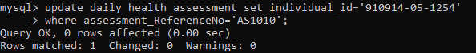

update daily_health_assessment set individual_id='951017-10-8076'

where assessment_referenceNo='AS1011';

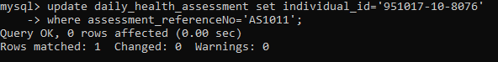

Select *from daily_health_assesment;

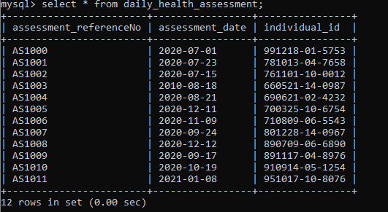

update test set individual_id='991218-01-5753'

where test_referenceNo='TS1001';

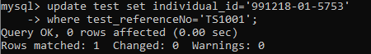

update test set individual_id='781013-04-7658'

where test_referenceNo='TS1002';

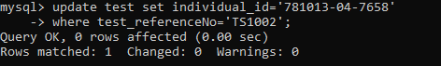

update test set individual_id='761101-10-0012'

where test_referenceNo='TS1003';

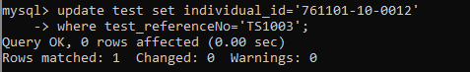

update test set individual_id='660521-14-0987'

where test_referenceNo='TS1004';

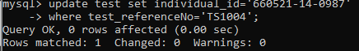

update test set individual_id='690621-02-4232'

where test_referenceNo='TS1005';

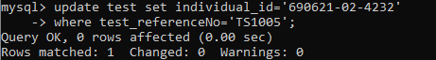

update test set individual_id='700325-10-6754'

where test_referenceNo='TS1006';

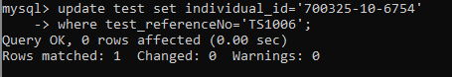

update test set individual_id='710809-06-5543'

where test_referenceNo='TS1007';

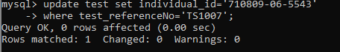

update test set individual_id='801228-14-0967'

where test_referenceNo='TS1008';

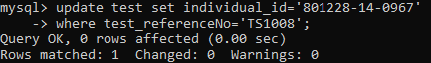

update test set individual_id='890709-06-6890'

where test_referenceNo='TS1009';

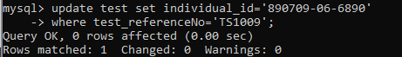

update test set individual_id='891117-04-8976'

where test_referenceNo='TS1010';

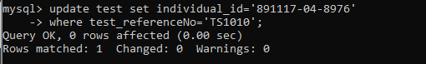

update test set individual_id='910914-05-1254'

where test_referenceNo='TS1011';

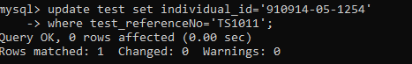

update test set individual_id='951017-10-8076'

where test_referenceNo='TS1012';

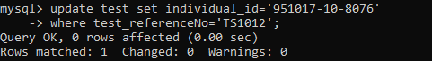

update test set test_result='Negative' where test_referenceNo='TS1001';  
update test set test_result='Negative' where test_referenceNo='TS1002'; update test set test_result='Negative' where test_referenceNo='TS1003'; update test set test_result='Negative' where test_referenceNo='TS1004'; update test set test_result='Negative' where test_referenceNo='TS1005'; update test set test_result='Negative' where test_referenceNo='TS1006'; update test set test_result='Negative' where test_referenceNo='TS1007'; update test set test_result='Negative' where test_referenceNo='TS1008'; update test set test_result='Negative' where test_referenceNo='TS1009'; update test set test_result='Negative' where test_referenceNo='TS1010'; update test set test_result='Positive' where test_referenceNo='TS1011'; update test set test_result='Negative' where test_referenceNo='TS1012';

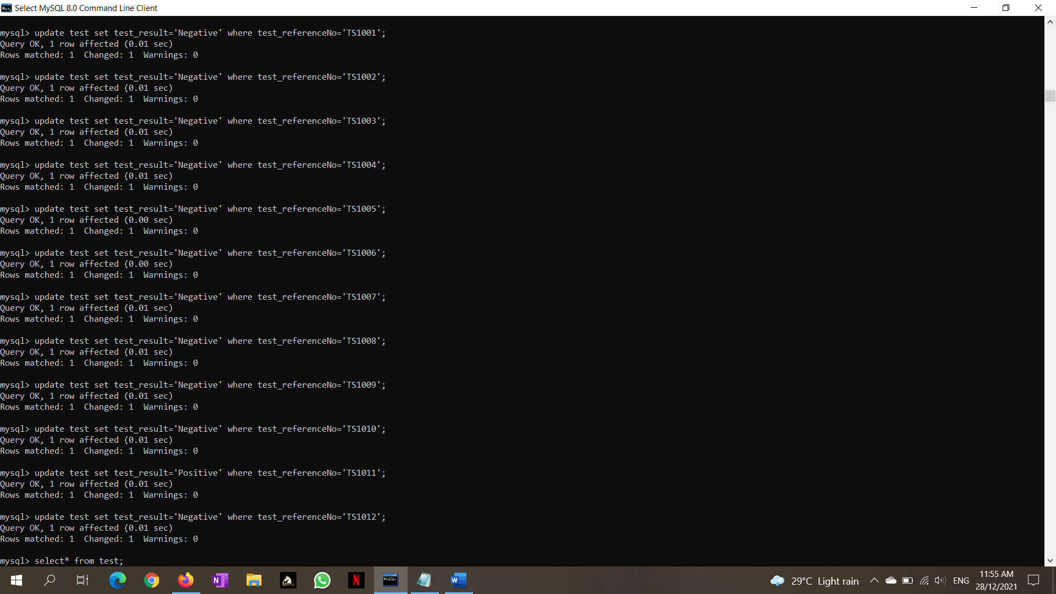

select * from test;

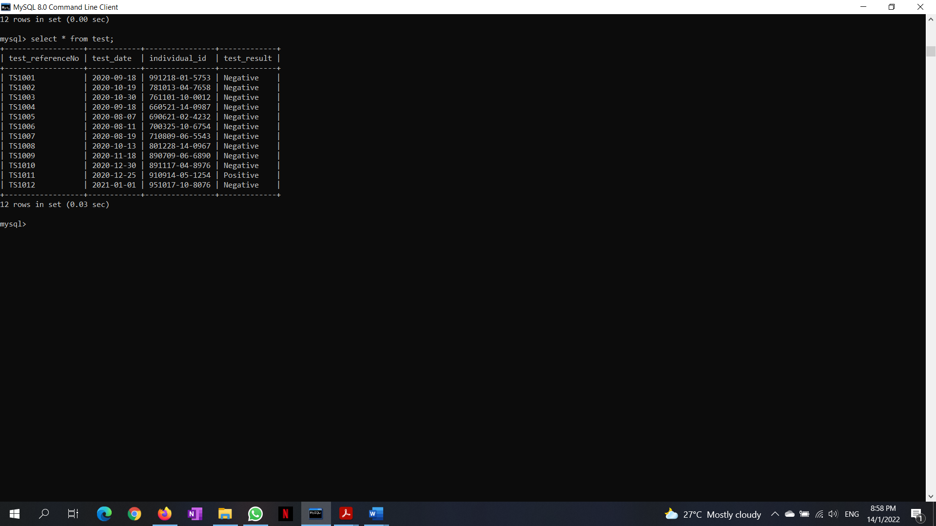

update applicant set vaccination_status_code='FV1000'

where applicant_id='A100';

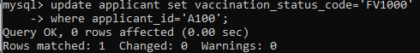

update applicant set vaccination_status_code='FV1001'

where applicant_id='A101';

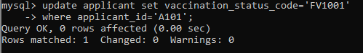

update applicant set vaccination_status_code='FV1002'

where applicant_id='A102';

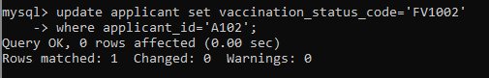

update applicant set vaccination_status_code='FV1003'

where applicant_id='A103';

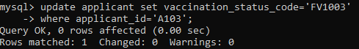

update applicant set vaccination_status_code='FV1004'

where applicant_id='A104';

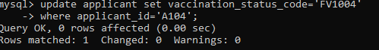

update applicant set vaccination_status_code='FV1005'

where applicant_id='A105';

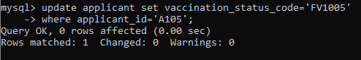

update applicant set vaccination_status_code='FV1006'

where applicant_id='A106';

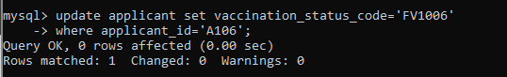

update applicant set vaccination_status_code='FV1007'

where applicant_id='A107';

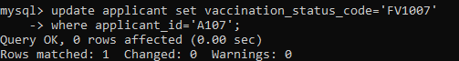

update applicant set vaccination_status_code='FV1008'

where applicant_id='A108';

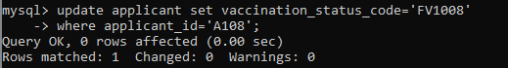

update applicant set vaccination_status_code='FV1009'

where applicant_id='A109'

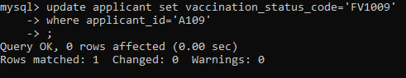

update applicant set vaccination_status_code='FV1010'

where applicant_id='A110';

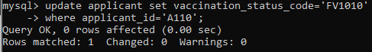

update applicant set vaccination_status_code='FV1011'

where applicant_id='A111';

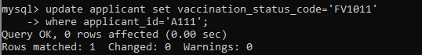

Select *from applicant;

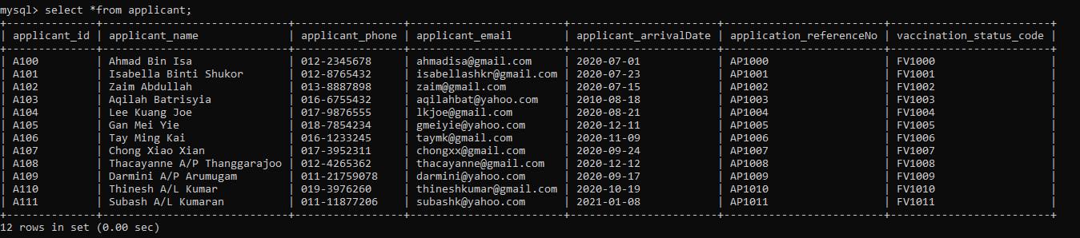

update vaccination set applicant_id='A100'

where vaccination_status_code='FV1000';

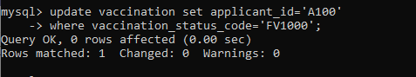

update vaccination set applicant_id='A101'

where vaccination_status_code='FV1001';

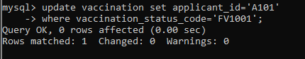

update vaccination set applicant_id='A102'

where vaccination_status_code='FV1002';

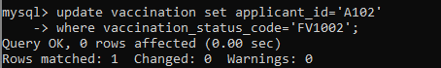

update vaccination set applicant_id='A103'

where vaccination_status_code='FV1003';

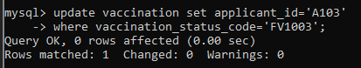

update vaccination set applicant_id='A104'

where vaccination_status_code='FV1004';

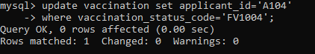

update vaccination set applicant_id='A105'

where vaccination_status_code='FV1005';

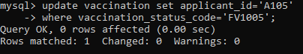

update vaccination set applicant_id='A106'

where vaccination_status_code='FV1006';

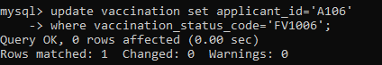

update vaccination set applicant_id='A107'

where vaccination_status_code='FV1007';

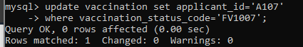

update vaccination set applicant_id='A108'

where vaccination_status_code='FV1008';

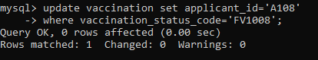

update vaccination set applicant_id='A109'

where vaccination_status_code='FV1009';

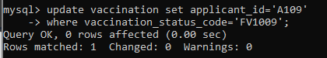

update vaccination set applicant_id='A110'

where vaccination_status_code='FV1010';

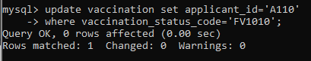

update vaccination set applicant_id='A111'

where vaccination_status_code='FV1011';

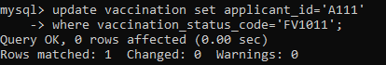

update vaccination set individual_id='991218-01-5753' where applicant_id='A100';

update vaccination set individual_id='781013-04-7658' where applicant_id='A101';

update vaccination set individual_id='761101-10-0012' where applicant_id='A102';

update vaccination set individual_id='660521-14-0987' where applicant_id='A103';

update vaccination set individual_id='690621-02-4232' where applicant_id='A104';

update vaccination set individual_id='700325-10-6754' where applicant_id='A105';

update vaccination set individual_id='710809-06-5543' where applicant_id='A106';

update vaccination set individual_id='801228-14-0967' where applicant_id='A107';

update vaccination set individual_id='890709-06-6890' where applicant_id='A108';

update vaccination set individual_id='891117-04-8976' where applicant_id='A109';

update vaccination set individual_id='910914-05-1254' where applicant_id='A110';

update vaccination set individual_id='951017-10-8076' where applicant_id='A111';

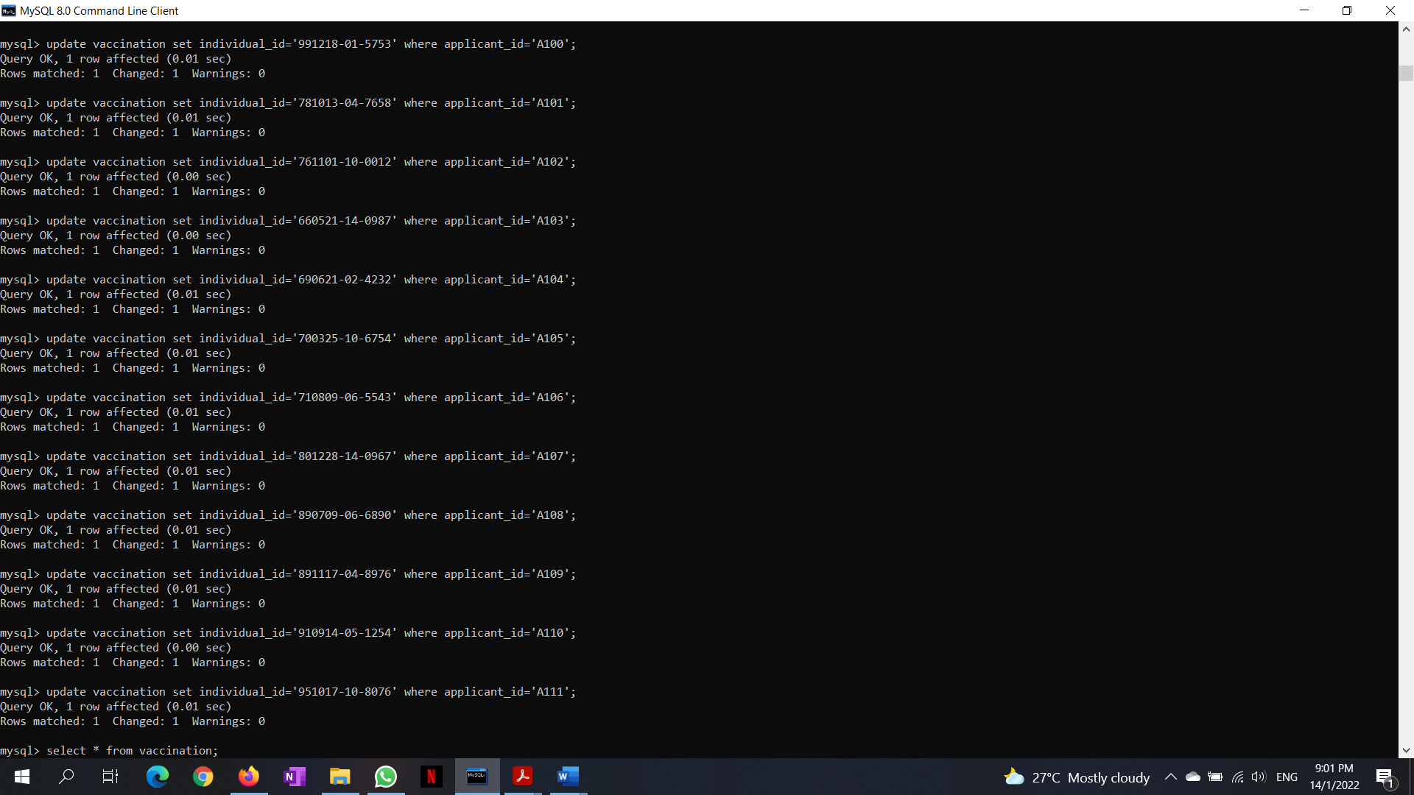

Select *from vaccination;

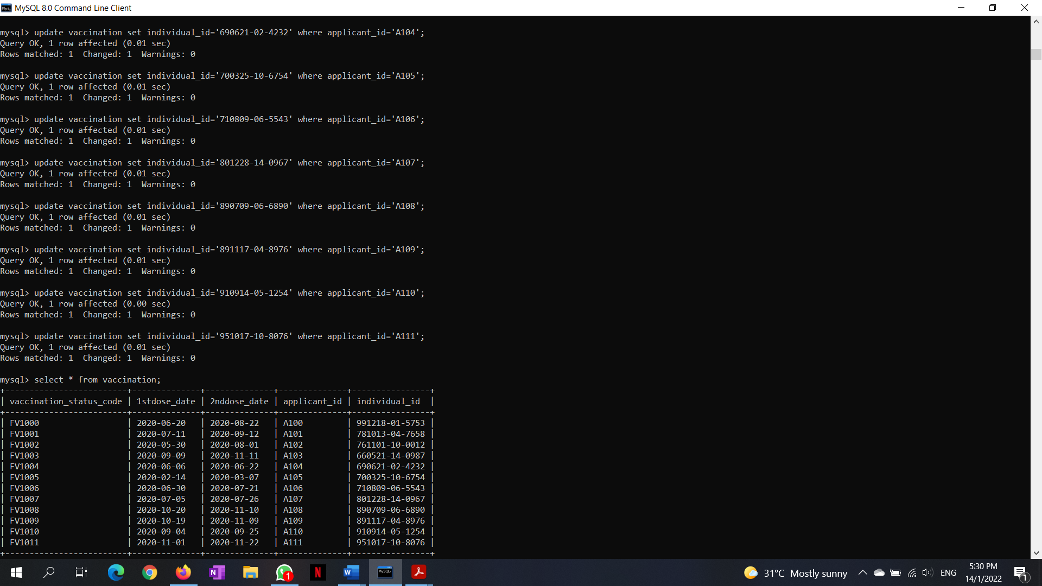

**Delete**

Delete from vaccination where vaccination_status_code= ‘FV1000’;

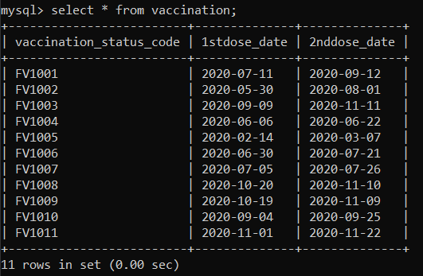

Delete from applicant where applicant_name=’Ahmad Bin Isa’;

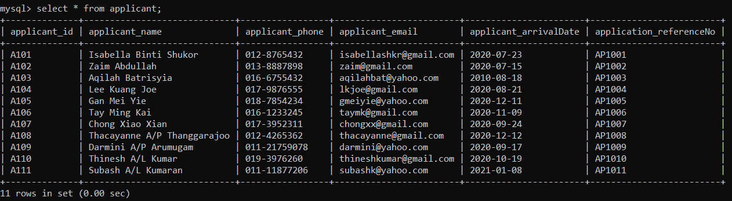

**FUNCTION**

select count(individual_name) as NumberOfVaccinator from home_quarantine_system.individual_entering_my;

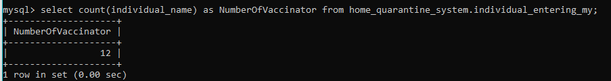

select individual_vacType as VaccineType, count(individual_vacType) as Total from individual_entering_my

group by individual_vacType

order by Total desc;

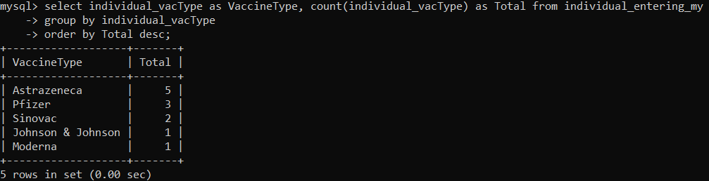

**DATE**

SELECT * FROM vaccination WHERE 1stdose_date='2020-09-09';

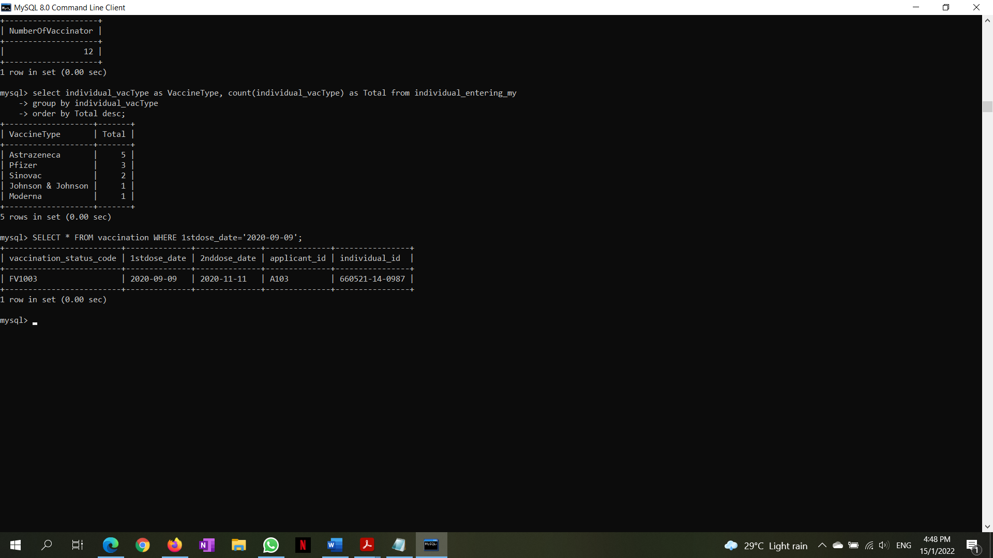

select assessment_date, assessment_referenceNo, COUNT(assessment_referenceNo)TotalReference from  home_quarantine_system.daily_health_assessment

where assessment_date >= '2020-07-01' and assessment_date <= '2020-12-12'

group by assessment_date, assessment_referenceNo;

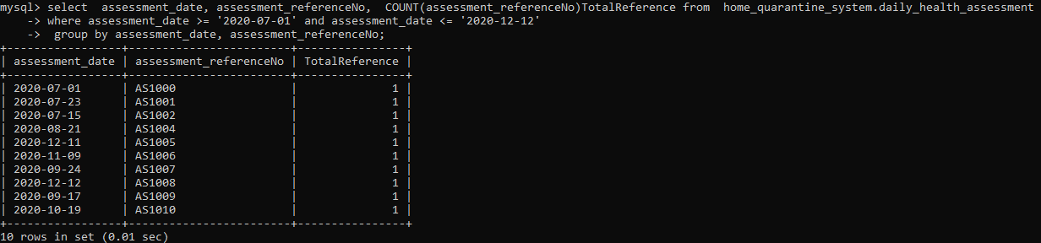

**JOINS**

select applicant_name, travel_departureCountry from applicant join application on applicant.application_referenceNo = application.application_referenceNo;

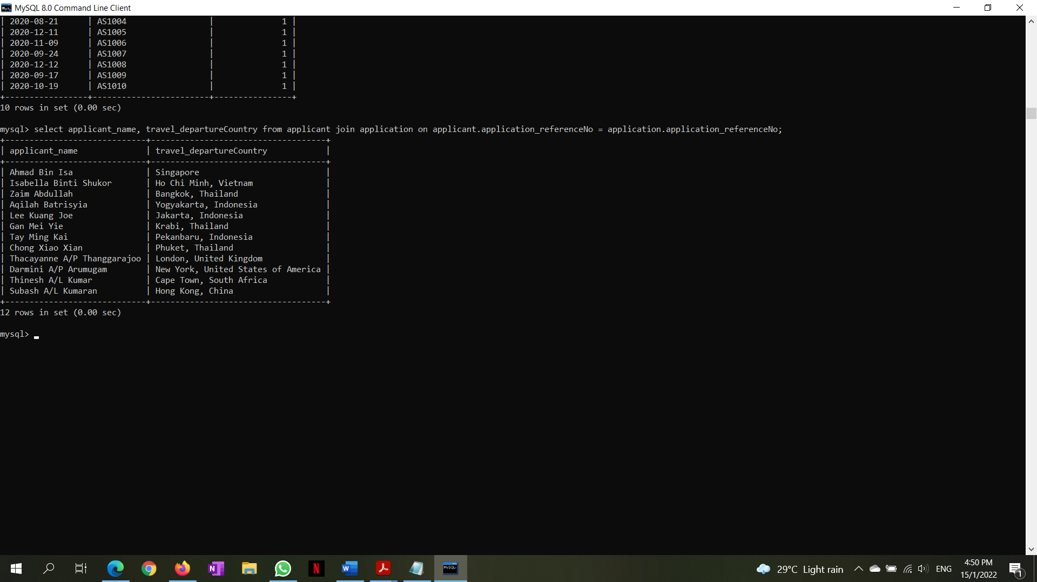

select applicant_name, 1stdose_date, 2nddose_date from applicant join vaccination on applicant.applicant_id=vaccination.applicant_id;

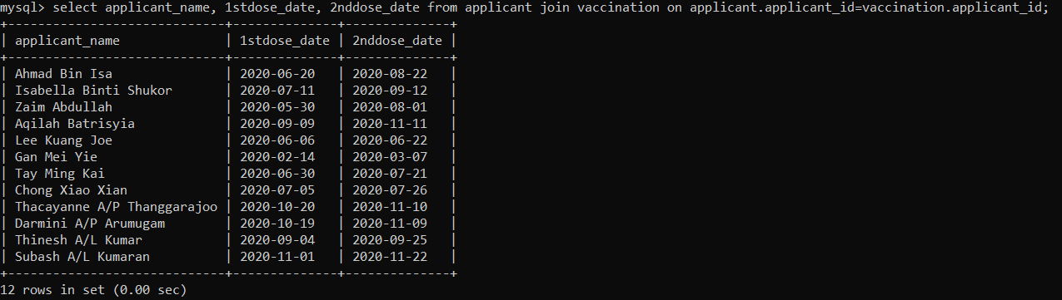

**SELECT**

select * from quarantine;

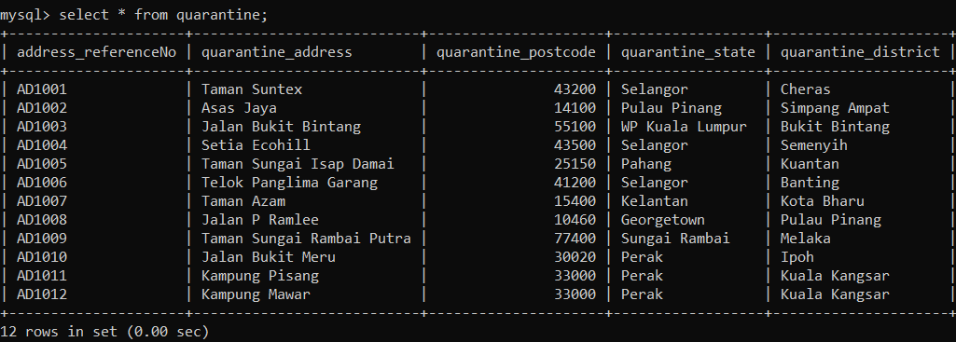

select * from individual_entering_my;

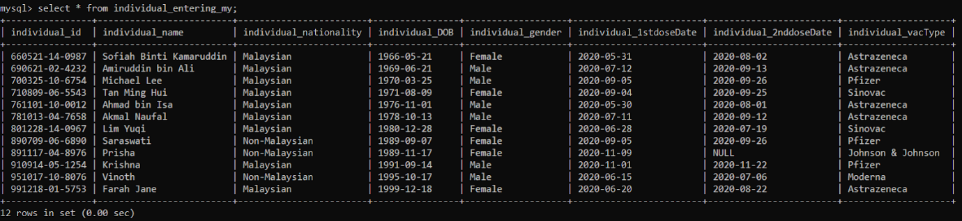

select * from transportation;

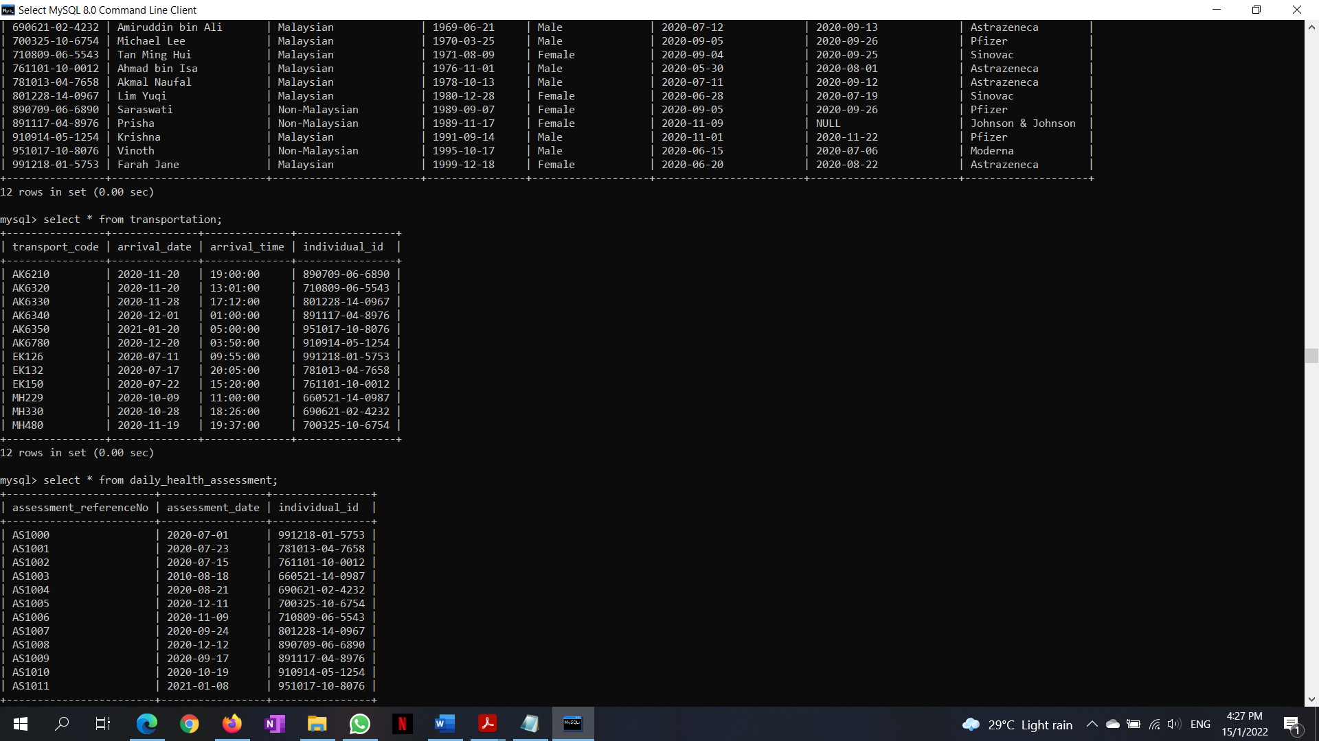

select * from daily_health_assessment;

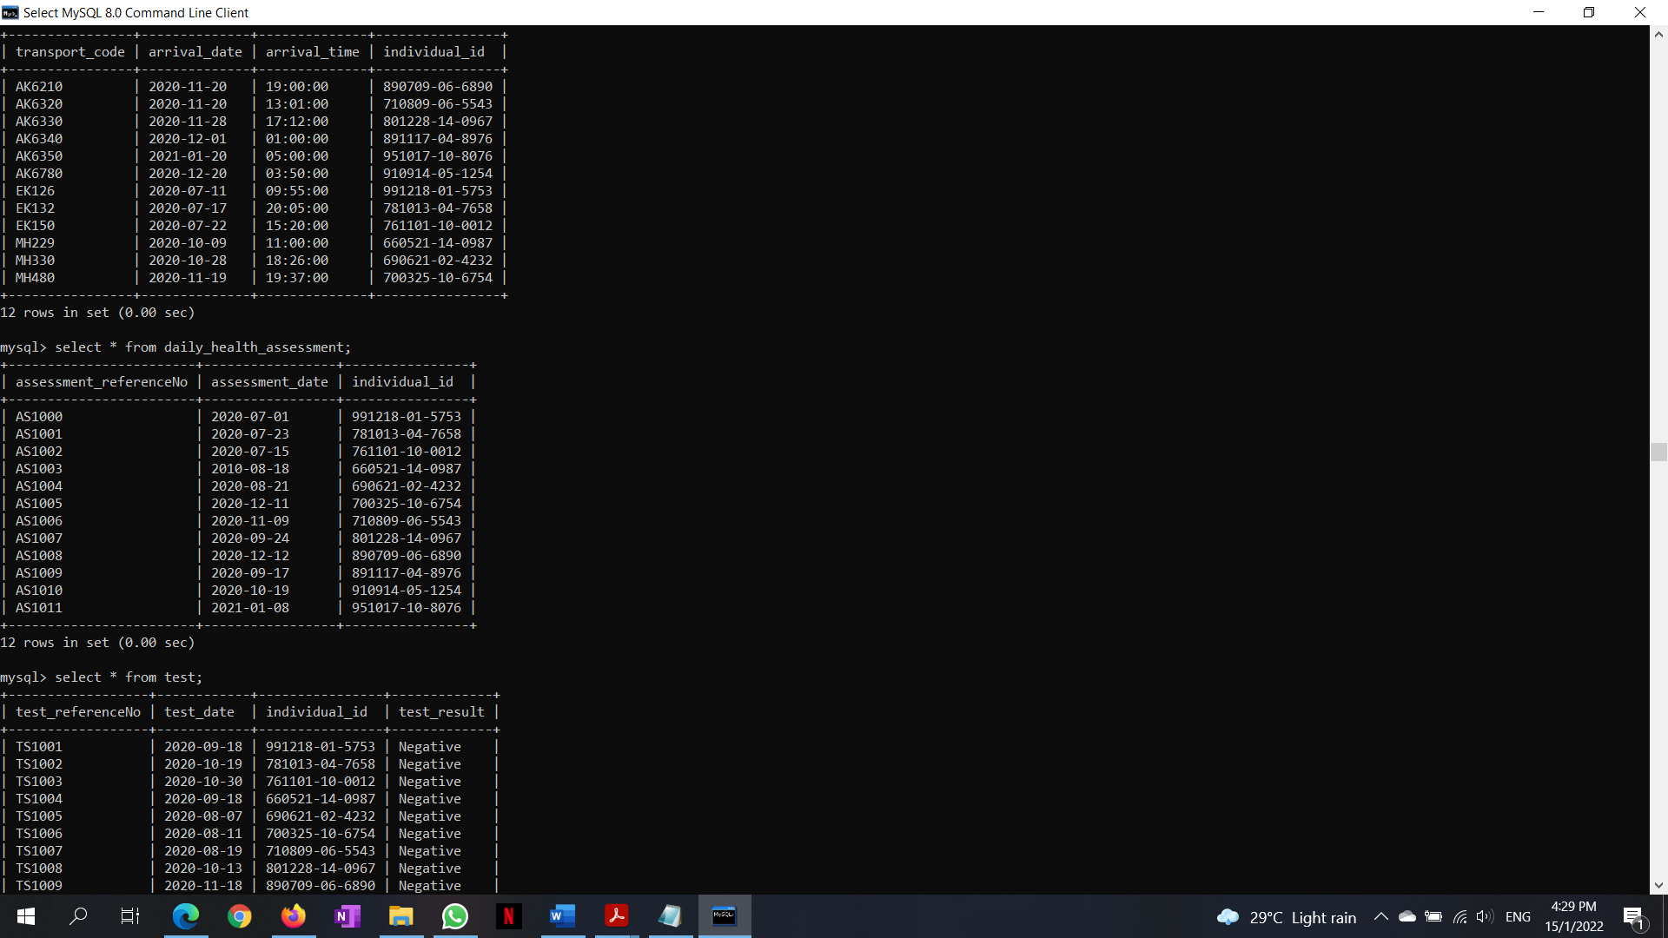

select * from test;

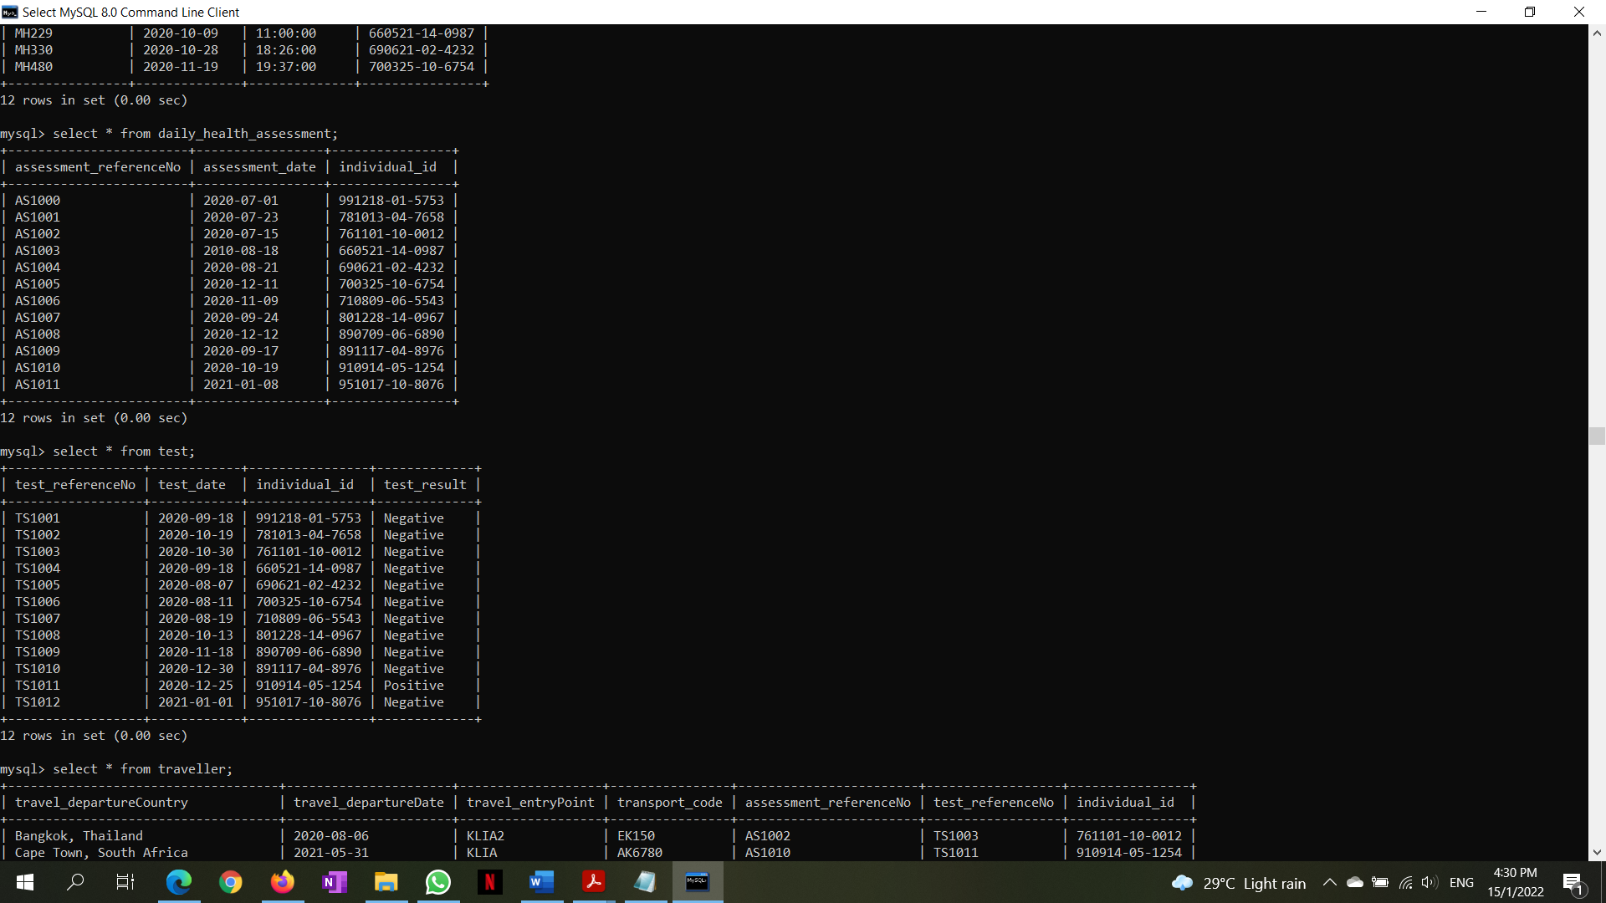

select * from traveller;

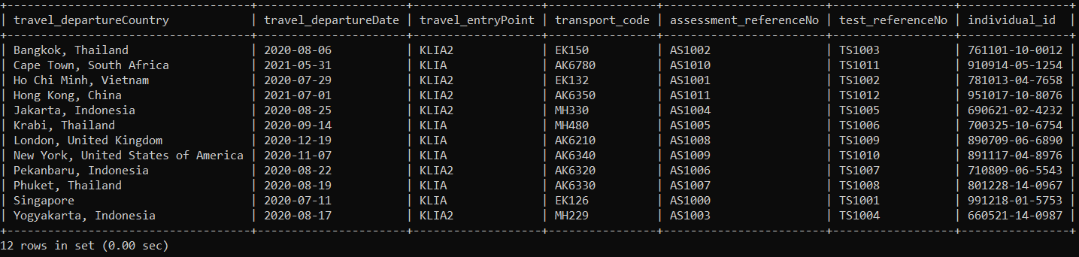

select * from application;

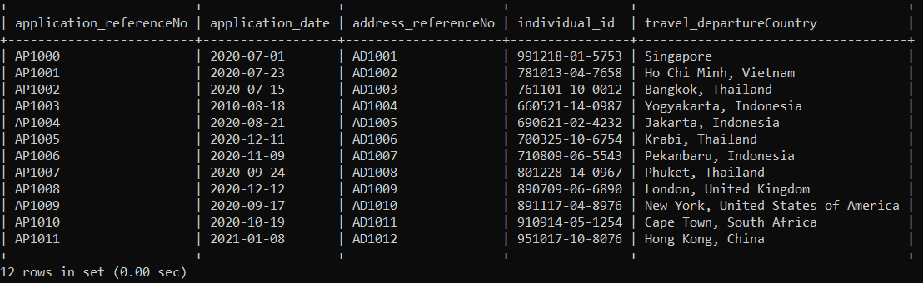

select * from vaccination;

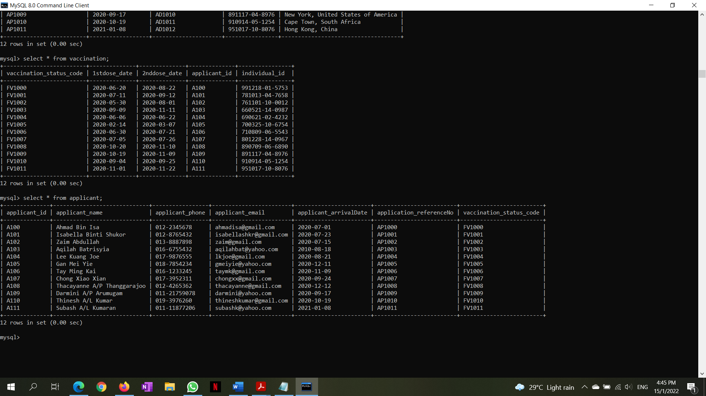

select * from applicant;



**7.0 Normalization**

**1NF**

Applicant (**applicant_id**, **application_refernceNo**, **vaccination_status_code**, applicant name, applicant_phone, applicant_email, applicant_arrivalDate, 1stdose_date, 2nddose_date, **address_referenceNo**, **individual_id**, **travel_departureCountry**, application_date, **transport_code**, **assessment_referenceNo**, **Test_referenceNo**, travel_departureDate, travel_entryPoint, test_date, test_result, assessment_date, arrival_date, arrival_time, individual_name, individual_nationality, individual_DOB, individual_gender, individual_1stdoseDate, individual_2nddoseDate, individual_vacType, quarantine_address, quarantine_postcode, quarantine_state, quarantine_district)

Partial dependencies:

(applicant_id -> applicant name, applicant_phone, applicant_email, applicant_arrivalDate)

(application_reference -> application_date)

(address_referenceNo -> quarantine_address, quarantine_postcode, quarantine_state, quarantine_district)

(individual_id-> individual_name, individual_nationality, individual_DOB, individual_gender, individual_1stdoseDate, individual_2nddoseDate, individual_vacType)

(travel_departureCountry -> travel_departureDate, transport_code, arrival_date, arrival_time) travel_entryPoint)

(assessment_referenceNo -> assessment_date)

(Test_referenceNo -> test_date, test_result)

(vaccination_status_code -> 1stdose_date, 2nddose_date)

Transitive Dependencies:

(transport_code -> arrival_date, arrival_time)

2NF

applicant(**applicant_id**, applicant name, applicant_phone, applicant_email, applicant_arrivalDate)

application(**application_referenceNo**, application_date)

quarantine(**address_referenceNo,** quarantine_address, quarantine_postcode, quarantine_state, quarantine_district)

individual_entering_my (**individual_id**, individual_name, individual_nationality, individual_DOB, individual_gender, individual_1stdoseDate, individual_2nddoseDate, individual_vacType)

traveller(**travel_departureCountry**, travel_departureDate, transport_code, arrival_date, arrival_time) travel_entryPoint)

daily_health_assessment(**assessment_referenceNo**, assessment_date)

test(**Test_referenceNo**, test_date, test_result)

vaccination(**vaccination_status_code**, 1stdose_date, 2nddose_date)

3NF

applicant(**applicant_id**, applicant name, applicant_phone, applicant_email, applicant_arrivalDate)

application(**application_referenceNo**, application_date)

quarantine(**address_referenceNo,** quarantine_address, quarantine_postcode, quarantine_state, quarantine_district)

individual_entering_my (**individual_id**, individual_name, individual_nationality, individual_DOB, individual_gender, individual_1stdoseDate, individual_2nddoseDate, individual_vacType)

traveller(**travel_departureCountry**, travel_departureDate, transport_code, arrival_date, arrival_time) travel_entryPoint)

daily_health_assessment(**assessment_referenceNo**, assessment_date)

test(**Test_referenceNo**, test_date, test_result)

vaccination(**vaccination_status_code**, 1stdose_date, 2nddose_date)

transportation(**transport_code**, arrival_date, arrival_time)

**8.0 Data Dictionary**

QUARANTINE ENTITY

|  |  |  |  |  |  |
| --- | --- | --- | --- | --- | --- |
| **NO** | **DATA** | **DESCRIPTION** | **TYPE** | **LENGTH** | **PK/FK** |
| 1. | address_referenceNo | Address reference number | VARCHAR | 50 | PK, NOT NULL |
| 2. | quarantine_address | Quarantine station address | VARCHAR | 50 |  |
| 3. | quarantine_postcode | Quarantine station postcode | INT |  |  |
| 4. | quarantine_state | Quarantine station state location | VARCHAR | 20 |  |
| 5 | quarantine_district | Quarantine station district | VARCHAR | 20 |  |

INDIVIDUAL ENTERING MALAYSIA ENTITY

|  |  |  |  |  |  |
| --- | --- | --- | --- | --- | --- |
| **NO** | **DATA** | **DESCRIPTION** | **TYPE** | **LENGTH** | **PK/FK** |
| 1. | individual_id | Individual ID | VARCHAR | 20 | PK,NOT NULL |
| 2. | individual_name | Individual name | VARCHAR | 50 |  |
| 3. | individual_nationality | Individual nationality | VARCHAR | 40 |  |
| 4. | individual_DOB | Date of birth of individual | Date |  |  |
| 5. | individual_gender | Individual gender category | VARCHAR | 10 |  |
| 6. | individual_1stdoseDate | Date of 1st dose inoculation for an individual | Date |  |  |
| 7. | individual_2nddoseDate | Date of 2nd dose  inoculation for an individual | Date |  |  |
| 8. | individual_vacType | Vaccine type taken by an individual | VARCHAR | 20 |  |

TRANSPORTATION ENTITY

|  |  |  |  |  |  |
| --- | --- | --- | --- | --- | --- |
| **NO** | **DATA** | **DESCRIPTION** | **TYPE** | **LENGTH** | **PK/FK** |
| 1. | transport_code | Transportation code | VARCHAR | 10 | PK,NOT NULL |
| 2. | arrival_date | Transportation arrival date | Date |  |  |
| 3. | arrival_time | Transportation arrival time | TIME |  |  |
| 4. | individual_ID | Individual_ID | VARCHAR | 20 | FK |

DAILY HEALTH ASSESSMENT ENTITY

|  |  |  |  |  |  |
| --- | --- | --- | --- | --- | --- |
| **NO** | **DATA** | **DESCRIPTION** | **TYPE** | **LENGTH** | **PK/FK** |
| 1. | assessment_referenceNo | Daily health assessment reference number | VARCHAR | 20 | PK,NOT NULL |
| 2. | assessment_date | Daily health assessment updated date | Date |  |  |
| 3. | individual_id | Individual ID | VARCHAR | 20 | FK |

TEST ENTITY

|  |  |  |  |  |  |
| --- | --- | --- | --- | --- | --- |
| **NO** | **DATA** | **DESCRIPTION** | **TYPE** | **LENGTH** | **PK/FK** |
| 1. | test_referenceNo | COVID-19 test reference number | VARCHAR | 20 | PK,NOT NULL |
| 2. | test_date | COVID-19 test date | Date |  |  |
| 3. | individual_id | Individual ID | VARCHAR | 20 | FK |

TRAVELLER ENTITY

|  |  |  |  |  |  |
| --- | --- | --- | --- | --- | --- |
| **NO** | **DATA** | **DESCRIPTION** | **TYPE** | **LENGTH** | **PK/FK** |
| 1. | travel_departureCountry | Traveler departure country | VARCHAR | 40 | PK,NOT NULL |
| 2. | transport_code | Transportation code | VARCHAR | 10 | FK |
| 3. | individual_id | Individual ID | VARCHAR | 20 | FK |
| 4. | assessment_referenceNo | Daily health assessment reference number | VARCHAR | 20 | FK |
| 5. | Test_referenceNo | COVID-19 test reference number | VARCHAR | 10 | FK |
| 6. | travel_departureDate | Traveler departure date | Date |  |  |
| 7. | travel_entryPoint | Traveler entry point | VARCHAR | 30 |  |

APPLICATION ENTITY

|  |  |  |  |  |  |
| --- | --- | --- | --- | --- | --- |
| **NO** | **DATA** | **DESCRIPTION** | **TYPE** | **LENGTH** | **PK/FK** |
| 1. | application_referenceNo | Application reference number | VARCHAR | 20 | PK,NOT NULL |
| 2. | address_referenceNo | Application address reference number | VARCHAR | 20 | FK |
| 3. | individual_id | Individual ID | VARCHAR | 20 | FK |
| 4. | travel_departureCountry | Traveler departure country | VARCHAR | 20 | FK |
| 5. | application_date | Application submitted date | Date |  |  |

VACCINATION ENTITY

|  |  |  |  |  |  |
| --- | --- | --- | --- | --- | --- |
| **NO** | **DATA** | **DESCRIPTION** | **TYPE** | **LENGTH** | **PK/FK** |
| 1. | vaccination_status_code | Vaccination status code | VARCHAR | 30 | PK,NOT NULL |
| 2. | applicant_id | Applicant ID | VARCHAR | 20 | FK |
| 3. | 1stdose_date | Date of 1st dose  inoculation | Date |  |  |
| 4. | 2nddose_date | Date of 2nd dose  inoculation | Date |  |  |

APPLICANT ENTITY

|  |  |  |  |  |  |
| --- | --- | --- | --- | --- | --- |
| **NO** | **DATA** | **DESCRIPTION** | **TYPE** | **LENGTH** | **PK/FK** |
| 1. | applicant_id | Applicant ID | VARCHAR | 20 | PK,NOT NULL |
| 2. | application_referenceNo | Application reference number | VARCHAR | 20 | FK |
| 3. | vaccination_status_code | vaccination status code | VARCHAR | 20 | FK |
| 4. | applicant_name | Applicant name | VARCHAR | 50 |  |
| 5. | applicant_phone | Applicant phone number | VARCHAR | 20 |  |
| 6. | applicant_email | Applicant email address | VARCHAR | 40 |  |
| 7. | applicant_arrivalDate | Applicant date of arrival | Date |  |  |

**9.0 References**

1. Reference: Portal Home Quarantine Application

<https://hso.moh.gov.my/outbreak-portal-hqa/index>

2. Reference: MySejahtera

<https://mysejahtera.malaysia.gov.my/intro/>

3.Tool used: Flowchart Maker & Online Diagram Software

<https://app.diagrams.net/>

4. Tool used: MYSQL 8.0 Command Line Client

**10.0 Appendix**

Meeting Report:

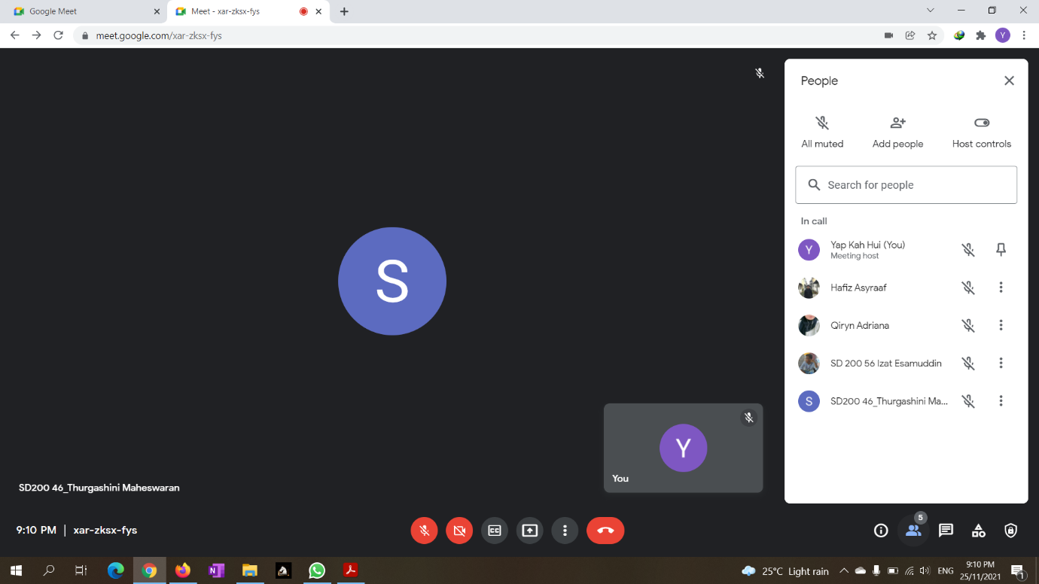

|  |  |  |  |  |
| --- | --- | --- | --- | --- |
| Group Meeting Report | | | | |
| Date and Time:  25 Nov 2021 | | Leader’s Name:  Yap Kah Hui | Attendees:   1. Yap Kah Hui 2. Hafiz Asyraaf 3. Qiryn Adriana 4. Izat Esamuddin 5. Thurgashini | |
|  | Task List: | Who is Responsible for the task? | The task involves which table? | Notes |
| 1. | Title, introduction, background, scope | Qiryn | - | - |
| 2. | Comparison between two case study databases | Yap | - | - |
| 3. | Business rule of case study databases | Thurga | - | - |
| 4. | ERD for case study database 1 | Hafiz | - | - |
| 5. | ERD for case study database 2 | Izat | - | - |

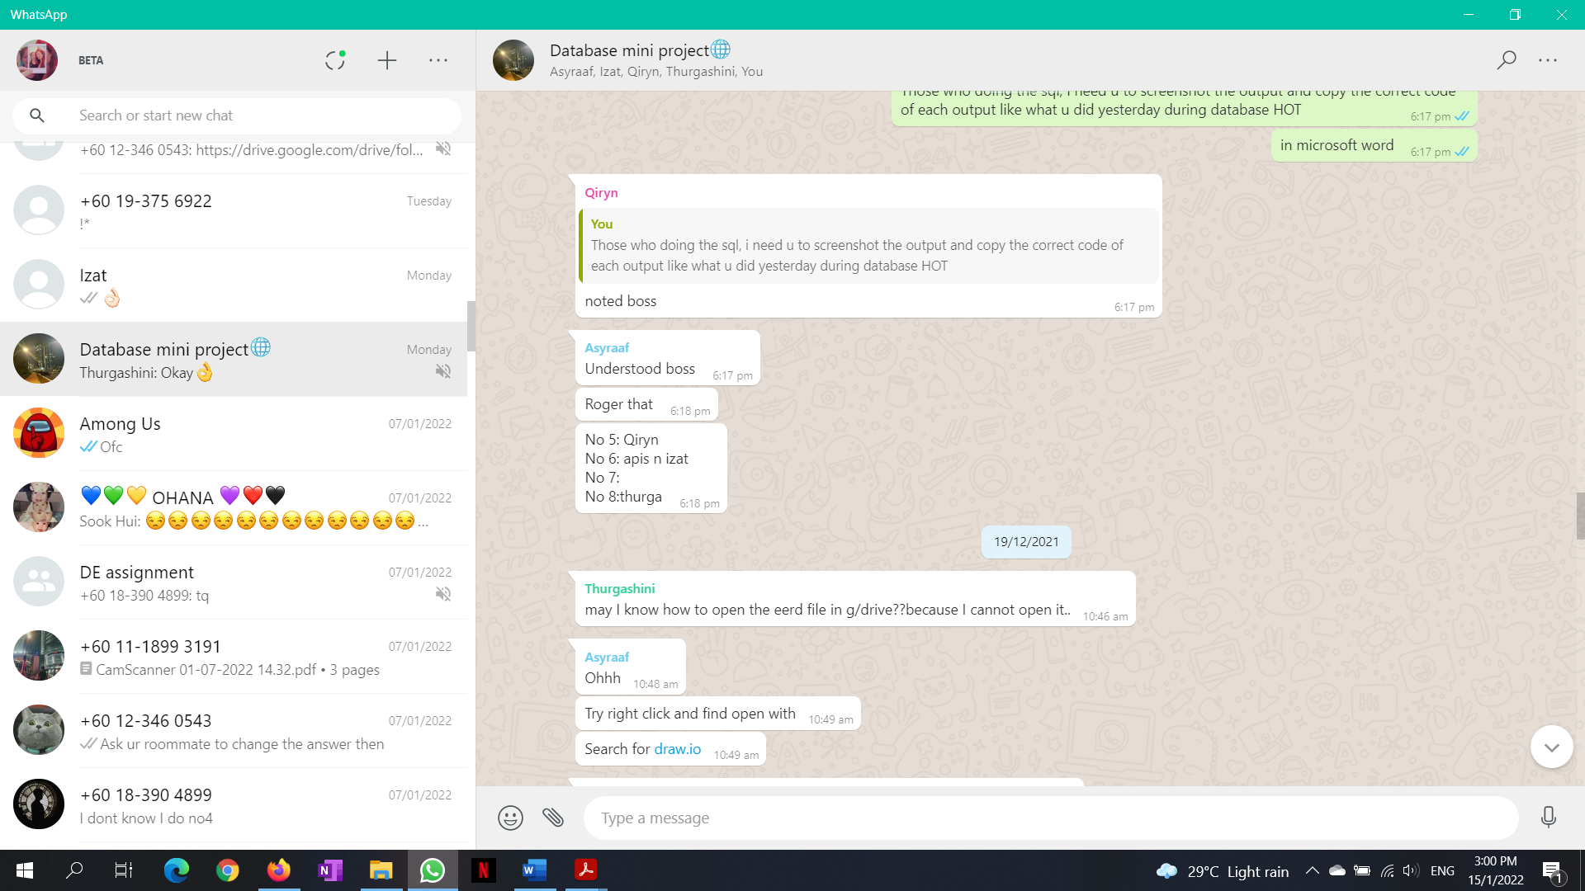

|  |  |  |  |  |
| --- | --- | --- | --- | --- |
| Group Meeting Report | | | | |
| Date and Time:  17 Dec 2021  Whatsapp discussion | | Leader’s Name:  Yap Kah Hui | Attendees:   1. Yap Kah Hui 2. Hafiz Asyraaf 3. Qiryn Adriana 4. Izat Esamuddin 5. Thurgashini | |
|  | Task List: | Who is Responsible for the task? | The task involves which table? | Notes |
| 1. | Data Definition Language | Qiryn | - | - |
| 2. | Data Manipulation Language | Hafiz, Izat | - | - |
| 3. | Normalization | Yap | - | - |
| 4. | Data Dictionary | Thurga | - | - |